CHAPTER 1

Introduction

Definition of Statistics

- in its plural sense, statistics is a set of numerical data (e.g., vital statistics in a beauty contest, monthly sales of a company, daily peso-dollar exchange rate)

- in its singular sense, Statistics is that branch of science which deals with the collection, presentation, analysis, and interpretation of data

1.1 NATURE OF STATISTICS

General Uses of Statistics

a. aids in decision making

- provides comparison
- explains action that has taken place
- justify a claim or assertion
- predicts future outcome
- estimates unknown quantities

b. summarizes data for public use

Examples on the Role of Statistics

- In the biological and medical sciences, it helps researchers discover relationships worthy of further attention.

Example: A doctor can use Statistics to determine to what extent is an increase in blood pressure dependent upon age.

- In the social sciences, it guides researchers and helps them support theories and models that cannot stand on rationale alone.

Example: Empirical studies are using Statistics to obtain socio-economic profile of the middle class to form new socio-political theories on classes as the existing theories apparently are no longer valid.

- In business, a company can use statistics to forecast sales, design products, and produce goods more efficiently.

Example: A pharmaceutical company can apply statistical procedures to find out if the new formula is indeed more effective than the one being used and the results can help the company decide whether to market the new formula or not.

- In engineering, it can be used to test properties of various materials.

Example: A quality controller can use Statistics to estimate the average lifetime of the products produced by their current equipment.

Fields of Statistics

a. Statistical Methods of Applied Statistics - refer to procedures and techniques used in the collection, presentation, analysis, and interpretation of data.

- Descriptive Statistics - comprise those methods concerned with the collection, description, and analysis of a set of data without drawing conclusions or inferences about a larger set
- the main concern is simply to describe the set of data such that otherwise obscure information is brought out clearly
- conclusions apply only to the data on hand

- Inferential Statistics - comprise those methods concerned with making predictions or inferences about a larger set of data using only the information gathered from a subset of this larger set
- the main concern is not merely to describe but actually predict and make inferences based on the information gathered
- conclusions are applicable to a larger set of data which the data on hand is only a subset

b. Statistical Theory of Mathematical Statistics - deals with the development and exposition of theories that serve as the bases of statistical methods.
Descriptive Statistics vs Inferential Statistics

 | Descriptive | Inferential
 | - A bowler wants to find his bowling average for the past 12 games | - A bowler wants to estimate his chance of winning a game based on his current season averages and the averages of his opponents
 | - A housewife wants to determine the average weekly amount she spent on groceries in the past 3 months | - A housewife would like to predict based on last year’s grocery bills, the average weekly amount she will spend on groceries for this year
 | - A politician wants to know the exact number of votes he received in the last election | - A politician would like to estimate, based on an opinion poll, his chance for winning in the upcoming election

1.2 POPULATION AND SAMPLE

Definition. A population is a collection of all the elements under consideration in a statistical study.

A sample is a part or subset of the population from which the information is collected.

Example: A manufacturer of kerosene heaters wants to determine if customers are satisfied with the performance of their heaters. Toward this goal, 5,000 of his 200,000 customers are contacted and each is asked, “Are you satisfied with the performance of the kerosene heater you purchased?” Identify the population and the sample for this situation.

Definition. A parameter is a numerical characteristic of the population.
A statistic is a numerical characteristic of the sample.

Example: In order to estimate the true proportion of students at a certain college who smoke cigarettes, the administration polled a sample of 200 students and determined that the proportion of students from the sample who smoke cigarettes is 0.12. Identify the parameter and the statistic.

CHAPTER 2

Collection and Presentation of Data

2.1 PRELIMINARIES

Steps in a Statistical Inquiry

- Define the problem.
- Formulate the research design.
- Collect the data.
- Code and analyze the collected data.
- Interpret the results.

Variables and Measurement

Definition. A variable is a characteristic or attribute of persons or objects which can assume different values or labels for different persons or objects under consideration.

Definition. Measurement is the process of determining the value or label of a particular variable for a particular experimental unit.

Definition. An experimental unit is the individual or object on which a variable is measured.

Classification of Variables

1. Discrete vs Continuous

Discrete variable - a variable which can assume finite, or, at most, countably infinite number of values; usually measured by counting or enumeration
Continuous variable - a variable which can assume the infinitely many values corresponding to a line interval

2. Qualitative vs Quantitative

Qualitative variable - a variable that yields categorical responses (e.g., political affiliation, occupation, marital status)
Quantitative variable- a variable that takes on numerical values representing an amount or quantity (e.g., weight, height, no. of cars)
Levels of Measurement:

1. Nominal Level (or Classificatory Scale)

The nominal level is the weakest level of measurement where numbers or symbols are used simply for categorizing subjects into different groups.

Examples:

Sex M-Male F-Female
Marital status 1-Single 2-Married 3-Widowed 4-Separated

2. Ordinal Level (or Ranking Scale)

The ordinal level of measurement contains the properties of the nominal level, and in addition, the numbers assigned to categories of any variable may be ranked or ordered in some low-to-high-manner.

Examples:

Teaching ratings 1-poor 2- fair 3-good 4-excellent
Year level 1-1st yr 2 – 2nd yr 3 – 3rd yr 4 – 4th yr

3. Interval Level

The interval level is that which has the properties of the nominal and ordinal levels, and in addition, the distances between any two numbers on the scale are of known sizes. An interval scale must have a common and constant unit of measurement. Furthermore, the unit of measurement is arbitrary and there is no “true zero” point.

Examples:

IQ
Temperature (in Celsius)

4. Ratio Level

The ratio level of measurement contains all the properties of the interval level, and in addition, it has a “true zero” point.
.
Examples:

Age (in years)
No. of correct answers in an exam
Classification of Data

1. Primary vs Secondary

a. Primary source - data measured by the researcher/agency that published it

b. Secondary source - any republication of data by another agency

Example: The publications of the National Statistics Office are primary sources and all subsequent publications of other agencies are secondary sources.

2. External vs Internal

a. Internal data - information that relates to the operations and functions of the organization collecting the data

b. External data - information that relates to some activity outside the organization collecting the data

Example: The sales data of SM is internal data for SM but external data for any other organization such as Robinson’s.

2.2 DATA COLLECTION METHODS

Data Collection Methods

1. Survey method - questions are asked to obtain information, either through self-administered questionnaire or personal interview

 | Self-administered questionnaire | Personal interview
 | - Obtained information is limited to subjects’ written answers to pre-arranged questions | - Missing information and vague responses are minimized with the proper probing of the interviewer
 | - Lower response rate | - Higher response rate through call-backs
 | - It can be administered to a large number of people simultaneously | - It is administered to a person or group one at a time
 | - Respondents may feel freer to express views and are less pressured to answer immediately | - Respondent may feel more cautious particularly in answering sensitive questions for fear of disapproval
 | - It is more appropriate for obtaining objective information | - It is more appropriate for obtaining about complex emotionally-laden topics or probing sentiments underlying an expressed opinion
2. Observation method - makes possible the recording of behavior but only at the time of occurrence (e.g., observing reactions to a particular stimulus, traffic count)

Advantages over Survey Method:

- does not rely on the respondent’s willingness to provide the desired data
- certain types of data can be collected only by observation (e.g. behavior patterns of which the subject is not aware of or is ashamed to admit)
- the potential bias caused by the interviewing process is reduced or eliminated

Disadvantages over Survey Method:

- things such as awareness, beliefs, feelings and preferences cannot be observed
- the observed behavior patterns can be rare or too unpredictable thus increasing the data collection costs and time requirements

3. Experimental method - a method designed for collecting data under controlled conditions. An experiment is an operation where there is actual human interference with the conditions that can affect the variable under study. This is an excellent method of collecting data for causation studies. If properly designed and executed, experiments will reveal with a good deal of accuracy, the effect of a change in one variable on another variable.

4. Use of existing studies - e.g., census, health statistics, and weather bureau reports

Two types:

- documentary sources - published or written reports, periodicals, unpublished documents, etc.

- field sources – researchers who have done studies on the area of interest are asked personally or directly for information needed

5. Registration method - e.g., car registration, student registration, and hospital admission

General Classification of Collecting Data

Definition. Census or complete enumeration is the process of gathering information from every unit in the population.

- not always possible to get timely, accurate and economical data
- costly, if the number of units in the population is too large

Definition. Survey sampling is the process of obtaining information from the units in the selected sample.

Advantages of Survey Sampling:

- reduced cost
- greater speed
- greater scope
- greater accuracy

2.3 PROBABILITY AND NON-PROBABILITY SAMPLING

Definition. A sampling procedure that gives every element of the population a (known) nonzero chance of being selected in the sample is called probability sampling. Otherwise, the sampling procedure is called non-probability sampling.

- Whenever possible, probability sampling is used because there is no objective way of assessing the reliability of inferences under non-probability sampling.

Definition. The target population is the population from which information is desired.

Definition. The sampled population is the collection of elements from which the sample is actually taken.

Definition. The population frame is a listing of all the individual units in the population.

Methods of Non-probability Sampling

1. purposive sampling - sets out to make a sample agree with the profile of the population based on some preselected characteristic

2. quota sampling - selects a specified number (quota) of sampling units possessing certain characteristics

3. convenience sampling- selects sampling units that come to hand or are convenient to get information from

4. judgment sampling - selects sample in accordance with an expert’s judgment

Methods of Probability Sampling

1. Simple random sampling
2. Stratified random sampling
3. Systematic sampling
4. Cluster sampling
5. Multi-stage sampling
6. Sequential sampling - units are drawn one by one in a sequence without prior fixing of the total number of observations and the results of the drawing at any stage are used to decide whether to terminate sampling or not

- Simple Random Sampling

Description of the Design

Simple random sampling is a method of selecting n units out of the N units in the population in such a way that every distinct sample of size n has an equal chance of being drawn. The process of selecting the sample must give an equal chance of selection to any one of the remaining elements in the population at any one of the n draws.

Random sampling may be with replacement (SRSWR) or without replacement (SRSWOR). In SRSWR, a chosen element is always replaced before the next selection is made, so that an element may be chosen more than once.

Sample Selection Procedure

Step 1: Make a list of the sampling units and number them from 1 to N.

Step 2: Select n (distinct for SRSWOR, not necessarily distinct for SRSWR) numbers from 1 to N using some random process, for example, the table of random numbers.

Step 3: The sample consists of the units corresponding to the selected random numbers.

Advantages

- The theory involved is much easier to understand than the theory behind other sampling designs.

- Inferential methods are simple and easy.

Disadvantages

- The sample chosen may be widely spread, thus entailing high transportation costs.

- A population frame, or list, is needed.

- Less precise estimates result if the population is heterogeneous with respect to the characteristic under study.

- Stratified Random Sampling

Description of the Design

In stratified random sampling, the population of N units is first divided into subpopulations called strata. Then a simple random sample is drawn from each stratum, the selection being made independently in different strata.

Sample Selection Procedure

Step 1: Divide the population into strata. Ideally, each stratum must consist of more or less homogeneous units.

Step 2: After the population has been stratified, a simple random sample is selected from each stratum.

Advantages

- Stratification may produce a gain in precision in the estimates of characteristics of the population

- It allows for more comprehensive data analysis since information is provided for each stratum.

- It is administratively convenient.

Disadvantages

- A listing of the population for each stratum is needed.

- The stratification of the population may require additional prior information about the population and its strata.

- Systematic Sampling

Description of the Design

Systematic sampling with a “random start” is a method of selecting a sample by taking every k^{th} unit from an ordered population, the first unit being selected at random. Here k is called the sampling interval; the reciprocal 1/k is the sampling fraction.

Sample Selection Procedure

Method A

Step 1: Number the units of the population consecutively from 1 to N.
Step 2: Determine k, the sampling interval using the formula k = N ÷ n.
Step 3: Select the random start r, where 1 < r < k. The unit corresponding to r is the first unit of the sample.
Step 4: The other units of the sample correspond to r + k, r + 2k, r + 3k, and so on.

Method B

Step 1: Number the units of the population consecutively from 1 to N.
Step 2: Let k be the nearest integer to N/n.
Step 3: Select the random start r, where 1 ≤ r ≤ N. The unit corresponding to r is the first unit of the sample.
Step 4: Consider the list of units of the population as a circular list, i.e., the last unit in the list is followed by the first. The other units in the sample are the units corresponding to r + k, r + 2k, r + 3k,..., r+ (n-1)k.

Advantages

- It is easier draw the sample and often easier to execute without mistakes than simple random sampling.
- It is possible to select a sample in the field without a sampling frame.
- The systematic sample is spread more evenly over the population.

Disadvantages

- If periodic regularities are found in the list, a systematic sample may consist only of similar types. (Example: Store sales over seven days of the week – estimating total sales based on a systematic sample every Tuesday would be unwise.)
- Knowledge of the structure of the population is necessary for its most effective use.

- Cluster Sampling

Description of the Design

Cluster sampling is a method of sampling where a sample of distinct groups, or clusters, of elements is selected and then a census of every element in the selected clusters is taken. Similar to strata in stratified sampling, clusters are non-overlapping sub-populations which together comprise the entire population. For example, a household is a cluster of individuals living together or a city block might also be considered as a cluster. Unlike strata, however, clusters are preferably formed with heterogeneous, rather than homogeneous elements so that each cluster will be typical of the population.

Clusters may be of equal or unequal size. When all of the clusters are of the same size, the number of elements in a cluster will be denoted by M while the number of clusters in the population will be denoted by N.

Sample-Selection Procedure

Step 1: Number the clusters from 1 to N.

Step 2: Select n numbers from 1 to N at random. The clusters corresponding to the selected numbers form the sample of clusters.

Step 3: Observe all the elements in the sample of clusters.

Advantages

- A population list of elements is not needed; only a population list of clusters is required. Listing cost is reduced.

- Transportation cost is reduced.

Disadvantages

- The costs and problems of statistical analysis are greater.

- Estimation procedures are more difficult.

- Multistage Sampling

Description of the Design

In multistage sampling, the population is divided into a hierarchy of sampling units corresponding to the different sampling stages. In the first stage of sampling, the population is divided into primary stage units (PSU) then a sample of PSU’s is drawn. In the second stage of sampling, each selected PSU is subdivided into second-stage units (SSU) then a sample of SSU’s is drawn. The process of subsampling can be carried to a third stage, fourth stage and so on, by sampling the subunits instead of enumerating them completely at each stage.

Advantages

- Listing cost is reduced.

- Transportation cost is reduced.

Disadvantages

- Estimation procedure is difficult, especially when the primary stage units are not of the same size.

- Estimation procedure gets more complicated as the number of sampling stages increases.

- The sampling procedure entails much planning before selection is done.

2.4 TABULAR AND GRAPHICAL PRESENTATION OF DATA

Textual Presentation

- data incorporated to a paragraph of text

Example

“At last count, 38 airlines were operating Boeing 707’s, 720’s, and 727’s over the world’s airlines. The far-flung Boeing fleet has now logged an estimated 1,803,704,000 miles (22,855,948,000 kms.) and has massed approximately 4,096,000 revenue flight hours. Passenger totals stand at upwards of 71.6 million.”

Advantages

- gives emphasis to significant figures and comparisons
- simplest and most appropriate approach when there are only a few numbers to be presented

Disadvantages

- when a large mass of quantitative data are included in a text or paragraph, the presentation becomes almost incomprehensible
- written paragraphs can be tiresome to read especially if the same words are repeated so many times

Tabular Presentation

- the systematic organization of data in rows and columns

Advantages

- more concise than textual presentation
- easy to understand
- facilitates comparisons & analysis of relationship among different categories
- presents data in greater detail than a graph

Parts of a Formal Statistical Table

- Heading - consists of a table number, title, and headnote. The title is a brief statement of the nature, classification and time reference of the information presented and the area to which the statistics refer. The headnote is a statement enclosed in brackets between the table title and the top rule of the table that provides additional title information.

- Box Head - the portion of the table that contains the column heads which describe the data in each column, together with the needed classifying and qualifying spanner heads.

- Stub - the portion of the table usually comprising the first column on the left, in which the stubhead and row captions, together with the needed classifying and qualifying center head and subheads are located. The stubhead describes the stub listing as a whole in terms of the classification presented. The row caption is a descriptive title of the data on the given line.

- Field - main part of the table; contains the substance or the figures of one’s data

- Source note - an exact citation of the source of data presented in the table (should always be placed when the figures are not original)

- Footnote - any statement or note inserted at the bottom of the table
heading
Table 4.4 – CRIME VOLUME AND RATE BY TYPE: 1991 – 1993
(Rate per 100,000 population)

stub  boxhead | 1991 |  | 1992 |  | 1993
Type | Volume | Crime  Rate | Volume | Crime  Rate | Volume | Crime  Rate
Total  field | 121,326 | 195 | 104,719 | 164 | 96,686 | 148
Index Crimes | 77,261 | 124 | 67,354 | 106 | 58,684 | 90
Murder | 8,707 | 14 | 8,293 | 13 | 7,758 | 12
Homicide | 8,069 | 13 | 7,912 | 12 | 7,123 | 11
Physical Injury | 21,862 | 35 | 20,462 | 32 | 18,722 | 29
Robbery | 13,817 | 22 | 11,164 | 18 | 9,856 | 15
Theft | 22,780 | 37 | 17,374 | 27 | 12,940 | 20
Rape | 2,026 | 3 | 2,149 | 3 | 2,285 | 4
Nonindex Crimes | 44,065 | 71 | 37,365 | 59 | 38,002 | 58
source
note
Source: Philippine National Police

Guidelines

- The title should be concise, written in telegraphic style, not in complete sentence.

- Column labels should be precise. Stress differences rather than similarities between adjacent columns. As much as possible, two or more adjacent columns should not begin nor end with the same phrase. This is frequently a signal that a spanner head is needed.

- The arrangement of lines in the stub depends on the nature of classification, purpose of presentation or limitations of space.

- Categories should not overlap.

- The units of measure must be clearly stated.

- Show any relevant total, subtotals, percentages, etc.

- Indicate if the data were taken from another publication by including a source note.

- Tables should be self-explanatory, although they may be accompanied by a paragraph that will provide an interpretation or direct attention to important figures.

Graphical Presentation

- a graph or chart is a device for showing numerical values or relationships in pictorial form

Advantages

- main features and implications of a body of data can be grasped at a glance
- can attract attention and hold the reader’s interest
- simplifies concepts that would otherwise have been expressed in so many words
- can readily clarify data, frequently bring out hidden facts and relationships

Qualities of a Good Graph

1. Accuracy - A good chart should not be deceptive, distorted, misleading, or in any way susceptible to wrong interpretations as a result of inaccurate or careless construction. Also, care should be taken so as not to create any optical illusion.

2. Clarity - An effective chart can be easily read and understood. The graph should focus on the message it is trying to communicate. There should be an unambiguous representation of the facts. The graph must be able to aid the reader in the interpretation of facts.

3. Simplicity - The basic design of a statistical chart should be simple, straight- forward, not loaded with irrelevant, superfluous, or trivial symbols and ornamentation. There should be no distracting elements in a chart that inhibit effective visual communication.

4. Appearance - A good chart is one that is designed and constructed to attract and hold attention by holding a neat, dignified, and professional appearance. It must be artistic in that it embodies harmonious composition, proportion, and balance.

Common Types of Graph

- 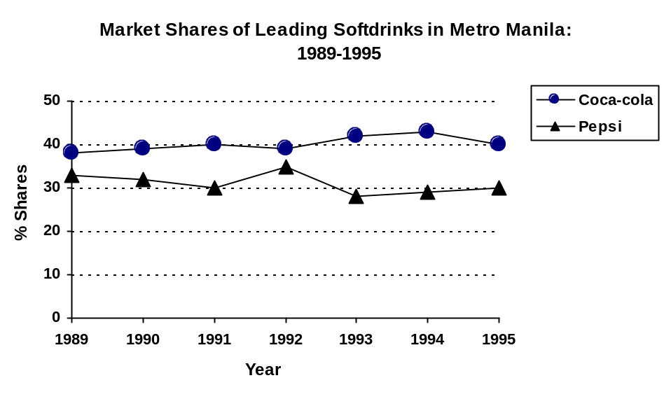Line Chart - graphical presentation of data especially useful for showing trends over a period of time.

- Pie Chart - a circular graph that is useful in showing how a total quantity is distributed among a group of categories. The “pieces of the pie” represent the proportions of the total that fall into each category.
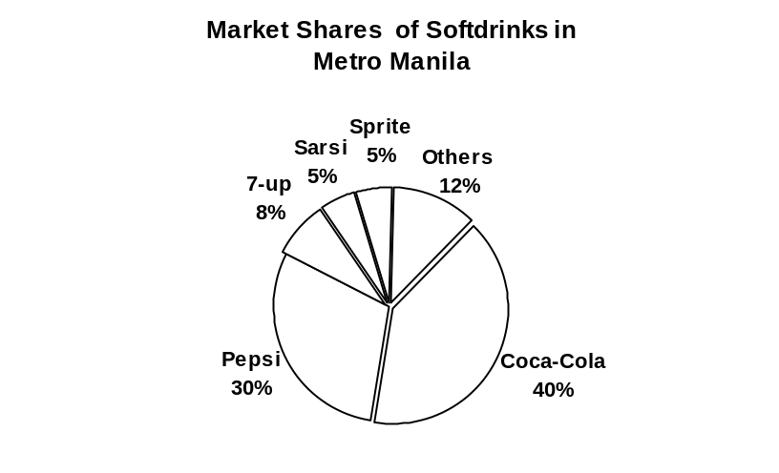

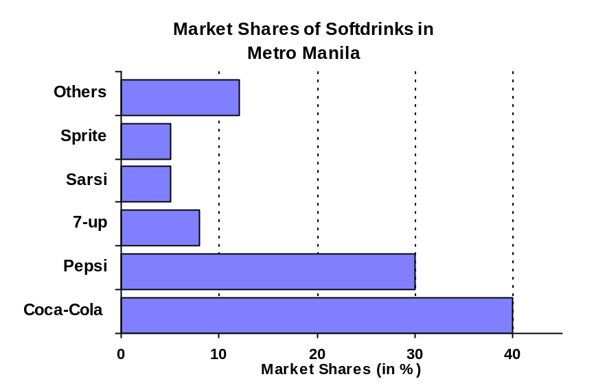3. Bar Chart - consists of a series of rectangular bars where the length of the bar represents the quantity or frequency for each category if the bars are arranged horizontally. If the bars are arranged vertically, the height of the bar represents the quantity.

- Pictorial unit chart – a pictorial chart in which each symbol represents a definite and uniform value
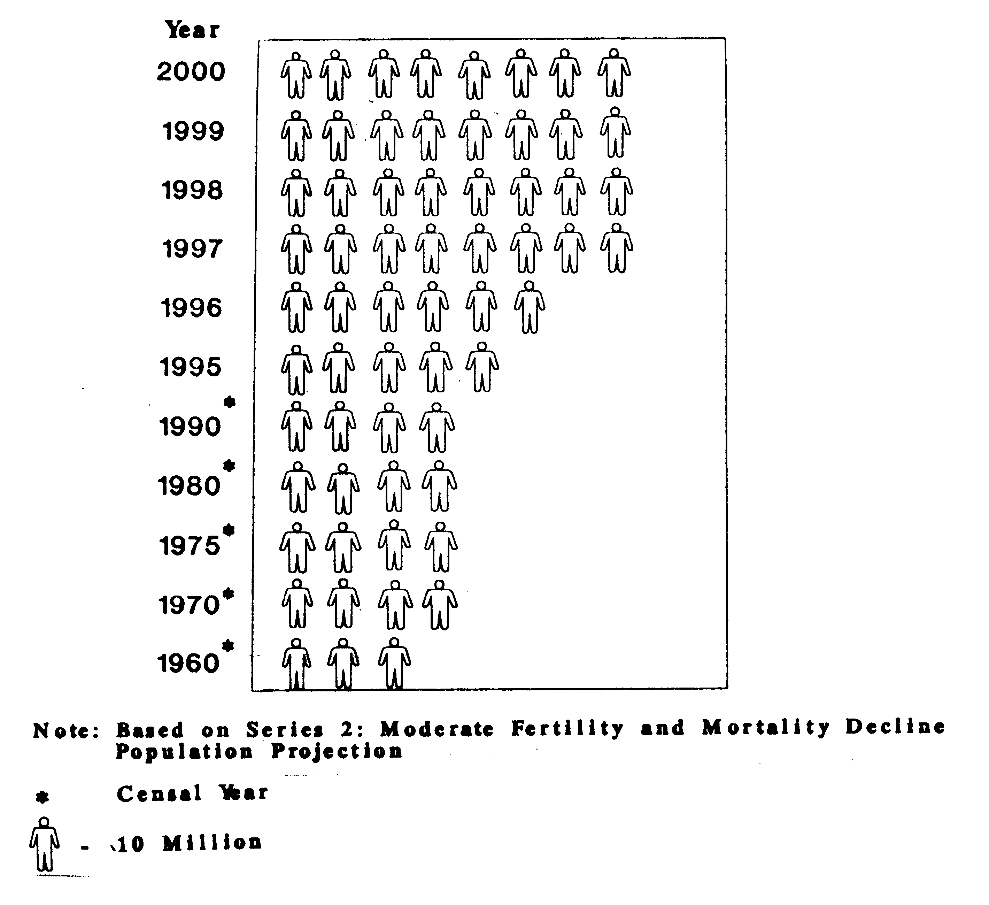
Growth Pattern of Philippine Population: 1960 - 2000

2.5 THE FREQUENCY DISTRIBUTION TABLE

Definition. The raw data is the set of data in its original form.

Example: Final grades of Stat 101 Students

82 82 83 79 72 71 84 59 77 50 87
83 82 63 75 50 85 76 79 68 69 62
79 69 74 53 73 71 50 76 57 81 62
72 88 84 80 68 50 74 84 71 73 68
71 80 72 60 81 89 94 80 84 81 50
84 76 75 82 76 53 91 69 60 89 79
59 62 79 82 72 81 60 84 68 66 94
77 78 87 75 86 82 74 73 72 84 51
50 69 75 70 77 87 86 77 75 96 66
87 73 84 68 85 62 87 92 69 52 65

Definition. An array is an arrangement of observations according to their magnitude, either in increasing or decreasing order.

Example: Final grades of Stat 101 Students arranged in an array

50 | 57 | 63 | 69 | 72 | 74 | 77 | 80 | 82 | 84 | 87
50 | 59 | 65 | 69 | 72 | 75 | 77 | 80 | 82 | 84 | 87
50 | 59 | 66 | 69 | 72 | 75 | 77 | 80 | 82 | 85 | 88
50 | 60 | 66 | 69 | 72 | 75 | 77 | 81 | 83 | 85 | 89
50 | 60 | 68 | 70 | 73 | 75 | 78 | 81 | 83 | 86 | 89
50 | 60 | 68 | 71 | 73 | 75 | 79 | 81 | 84 | 86 | 91
51 | 62 | 68 | 71 | 73 | 76 | 79 | 81 | 84 | 87 | 92
52 | 62 | 68 | 71 | 73 | 76 | 79 | 82 | 84 | 87 | 94
53 | 62 | 68 | 71 | 74 | 76 | 79 | 82 | 84 | 87 | 94
53 | 62 | 69 | 72 | 74 | 76 | 79 | 82 | 84 | 87 | 96

Advantages:

- easier to detect the smallest and largest value
- easier to find the measures of position

In the construction of a frequency distribution, the various items of a series are classified into groups. The frequency distribution table shows the number of items falling into each group.

Definition of terms

1. Class frequency - the number of observations falling in the class
2. Class interval - the numbers defining the class
3. Class limits - the end numbers of the class
4. Class boundaries - the true class limits; the lower class boundary (LCB) is usually defined as halfway between the lower class limit of the class and the upper class limit of the preceding class while the upper class boundary (UCB) is usually defined as halfway between the upper class limit of the class and the lower class limit of the next class
5. Class size - the difference between the upper class boundaries of the class and the preceding class; can also be computed as the difference between the lower class boundaries of the next class and the class; can also be computed by using the respective class limits instead of the class boundaries
6. Class mark (CM) - midpoint of a class interval
7. Open-end class - a class that has no lower limit or upper limit

Examples:

 | Class | Freq. | LCB | UCB | CM
 | 50 – 55  56 – 61  62 – 67  68 – 73  74 - 79  80 – 85  86 – 91  92 – 97 | 10  6  8  24  22  24  12  4 | 49.5  55.5  61.5  67.5  73.5  79.5  85.5  91.5 | 55.5  61.5  67.5  73.5  79.5  85.5  91.5  97.5 | 52.5  58.5  64.5  70.5  76.5  82.5  88.5  94.5
O R
 | Class | Freq. | LCB | UCB | CM
 | 50 – 54  55 – 59  60 – 64  65 – 69  70 – 74  75 – 79  80 – 84  85 – 89  90 – 94  95 – 99 | 10  3  8  13  17  19  22  13  4  1 | 49.5  54.5  59.5  64.5  69.5  74.5  79.5  84.5  89.5  94.5 | 54.5  59.5  64.5  69.5  74.5  79.5  84.5  89.5  94.5  99.5 | 52  57  62  67  72  77  82  87  92  97

Steps in Constructing a Frequency Distribution Table

- Determine the number of classes. There must be an adequate number of classes to show the essential characteristics of the data; at the same time, there should not be too many classes that it is already difficult to grasp the picture of the distribution as a whole. There are no precise rules concerning the optimal number of classes but Sturges’ formula can be used as a first approximation.

Sturges’ formula: K = 1 + 3.322 log n
= approximate number of classes
n = number of observations

- Determine the approximate class size. Whenever possible, all classes should be of the same size. The following steps can be used to determine the class size.

- Solve for the range, R = max – min.
- Compute for C’ = R ÷ K.
- Round-off C’ to a convenient number to work with, say C, and use C as the class size.

- Determine the lowest class limit. The first class must include the smallest value in the data set.

- Determine all class limits by adding the class size, C, to the limit of the previous class.

- Tally the frequencies for each class. Sum the frequencies and check against the total number of observations.

Variations of the Frequency Distribution

1. Relative Frequency (RF) Distribution and Relative Frequency Percentage (RFP)

RF = class frequency ÷ no. of observations
RFP = RF * 100%

2. Cumulative Frequency Distribution (CFD)
- shows the accumulated frequencies of successive classes, beginning at either end of the distribution

Greater than CFD – shows the no. of observations greater than the LCB
Less than CFD – shows the no. of observations less than the UCB

Example:

Class | Freq. | LCB | UCB | RF | RFP | <CF | >CF
50 – 54  55 – 59  60 – 64  65 – 69  70 – 74  75 – 79  80 – 84  85 – 89  90 – 94  95 – 99 | 10  3  8  13  17  19  22  13  4  1 | 49.5  54.5  59.5  64.5  69.5  74.5  79.5  84.5  89.5  94.5 | 54.5  59.5  64.5  69.5  74.5  79.5  84.5  89.5  94.5  99.5 | .09  .03  .07  .12  .15  .17  .20  .12  .04  .01 | 9  3  7  12  15  17  20  12  4  1 | 10  13  21  34  51  70  92  105  109  110 | 110  100  97  89  76  59  40  18  5  1

Graphical Presentation of the Frequency Distribution Table

1. Frequency Histogram - a bar graph that displays the classes on the horizontal axis and the frequencies of the classes on the vertical axis; the vertical lines of the bars are erected at the class boundaries and the height of the bars correspond to the class frequency
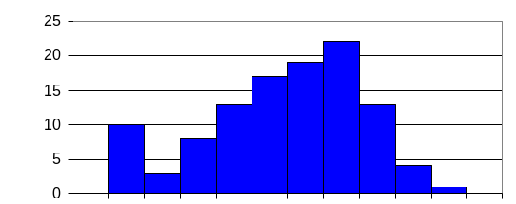
49.554.559.564.569.574.579.584.589.594.599.5

Grades
No. of Students
No. of Students

2. Relative Frequency Histogram - a graph that displays the classes on the horizontal axis and the relative frequencies on the vertical axis

Note: The relative frequency histogram has the same shape as the frequency histogram but has a different vertical axis.
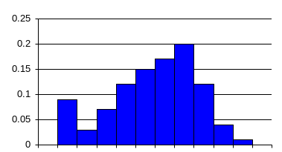
49.554.559.564.569.574.579.584.589.594.599.5
Grades
Relative
Freq.

3. Frequency Polygon – a line chart that is constructed by plotting the frequencies at the class marks and connecting the plotted points by means of straight lines; the polygon is closed by considering an additional class at each end and the ends of the lines are brought down to the horizontal axis at the midpoints of the additional classes.
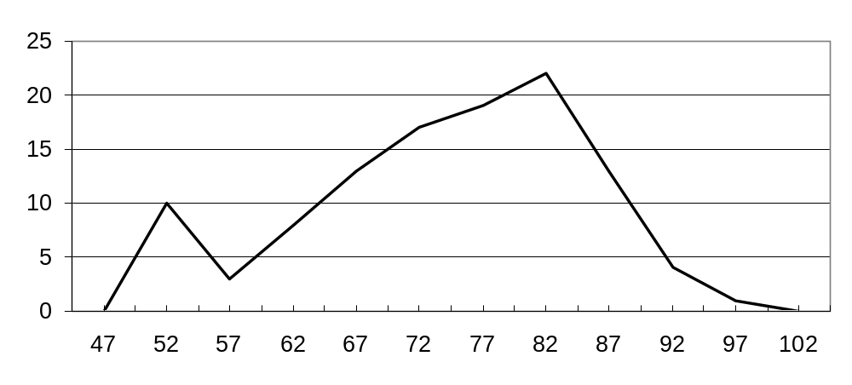
No. of
students
Grades
4. Ogives - graphs of the cumulative frequency distribution

a. < ogive - the <CF is plotted against the UCB
b. > ogive - the >CF is plotted against the LCB

0
20
40
60
80
100
120
< ogive
> ogive
49.5
59.5
69.5
79.5
89.5
99.5
Grades
Cumulative
Frequency

2.6 THE STEM-AND-LEAF DISPLAY

The stem-and-leaf display is an alternative method for describing a set of data. It presents a histogram-like picture of the data, while allowing the experimenter to retain the actual observed values of each data point. Hence, the stem-and-leaf display is partly tabular and partly graphical in nature.

In creating a stem-and-leaf display, we divide each observation into two parts, the stem and the leaf. For example, we could divide the observation 244 as follows:

Stem Leaf
2 | 44

Alternatively, we could choose the point of division between the units and tens, whereby

Stem Leaf
24 | 4

The choice of the stem and leaf coding depends on the nature of the data set.
Steps in Constructing the Stem-and-Leaf Display

1. List the stem values, in order, in a vertical column.

2. Draw a vertical line to the right of the stem value.

3. For each observation, record the leaf portion of that observation in the row corresponding to the appropriate stem

4. Reorder the leaves from lowest to highest within each stem row. Maintain uniform spacing for the leaves so that the stem with the most number of observations has the longest line.

5. If the number of leaves appearing in each row is too large, divide the stem into two groups, the first corresponding to leaves beginning with digits 0 through 4 and the second corresponding to leaves beginning with digits 5 through 9. this subdivision can be increased to five groups if necessary.

6. Provide a key to your stem-and-leaf coding so that the reader can recreate the actual measurements from your display.

Example: Typing speeds (net words per minute) for 20 secretarial applicants
68 72 91 47
52 75 63 55
65 35 84 45
58 61 69 22
46 55 66 71

Stem | Leaf (unit = 1)
2  3  4  5  6  7  8  9 | 2  5  5 6 7  2 5 5 8  1 3 5 6 8 9  1 2 5  4  1

Note: The stem-and-leaf display should include a reminder indicating the units of the data value.

Example:
Unit = 0.1 1 | 2 represents 1.2
Unit = 1 1 | 2 represents 12
Unit = 10 1 | 2 represents 120

CHAPTER 3

Measures of Central Tendency
and
Measures of Location

Definition. A measure of central tendency is any single value that is used to identify the “center” of the data or the typical value. It is often referred to as the average.

Characteristics of a Good Average

1. easily understood
- not a distant mathematical abstraction

2. objective and rigidly defined
- should encounter no question as to what the value is

3. stable
- not affected materially by minor variations in the groups of items

4. easily amenable to further statistical computation

3.1 NOTATIONS AND SYMBOLS

Suppose that a variable X is the variable of interest, and that n measurements are taken. The notation X₁, X₂, . . . ,X_{n} will be used to represent the n observations.

Let the Greek letter Σ indicate the “summation of,” thus, we can write the sum of the observations as 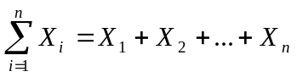.

The numbers 1 and n are called the lower and the upper limits of summation, respectively.

Some Results on Summation

1. The summation of the sum of variables is the sum of their summations.

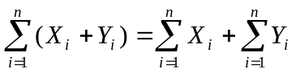

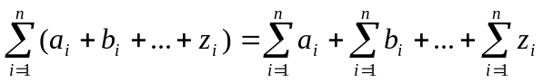

2. If c is a constant, then

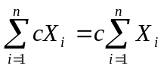

- If c is a constant then

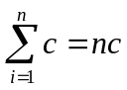

Examples :

Given:
i | 1 | 2 | 3 | 4
X_{i} | 2 | 4 | 6 | 8
Y_{i} | 1 | 2 | 1 | 2

Show:

1. 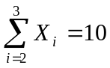 4. 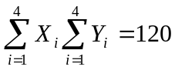

2. 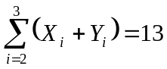 5. 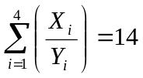

3. 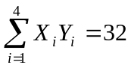 6. 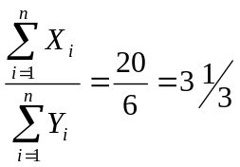

3.2 THE ARITHMETIC MEAN

- the most common average
- the sum of all values of the observations divided by the number of observations
- simply referred to as the mean

The population mean for a finite population with N elements, denoted by the Greek letter μ (mu), is computed as 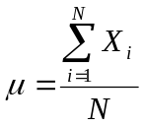.
The sample mean  (read as “X bar”) of n observations is computed as 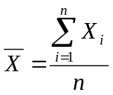.

The sample mean (a statistic) is an estimate of the unknown population mean (a parameter).

Examples:

1. The number of employees at 5 different drug stores are 10, 12, 6, 8, and 4. Treating the data as a population, find the mean number of employees for the 5 stores.

2. Scores in the Statistics 101 first exam for a sample of 10 students are as follows: 60, 55, 30, 90, 88, 79, 45, 66, 93, and 80. Find the mean.

3. Refer to the example on the final grades of 110 Statistics 101 students. The sample mean is given by 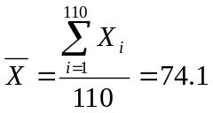.

Definition. The weighted mean is a modification of the usual mean that assigns weights (or measures of relative importance) to the observations to be averaged. If each observation X_{i} is assigned a weight W_{i}, i = 1, 2,…, n, the weighted mean is given by 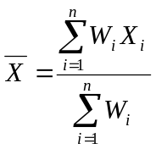.

Examples:

1. Suppose a teacher assigns the following weights to the various course requirements:

Assignment 15% Project 25%
Midterm Exam 20%
Final Exam 40%

The maximum score a student may obtain for each component is 100. Jeffry obtains marks of 83 for assignments, 72 for the project, 41 for the midterm exam, and 47 for the final exam. Find his mean mark for the course.

2. Alex’s grades for the second semester AY 1996-1997 are as follows:

History 1.0
Humanities 1.0
Math 19 3.0
Math 53 3.0
Philosophy 1.0

Math 53 is a 5-unit course and all others are 3-unit courses. Find Alex’s GWA for the semester.

Characteristics of the Mean

1. It is the most familiar measure used, and it employs all available information.

2. It is affected by the value of every observation. In particular it is strongly influenced by extreme values.

3. Since the mean is a calculated number, it may not be an actual number in the data set.

4. It possesses two mathematical properties that will prove to be important in subsequent analyses.
i) The sum of the deviations of the values from the mean is zero.
ii) The sum of the squared deviations is minimum when the deviations are taken from the mean.

5. a. If a constant c is added (subtracted) to all observations, the mean of the new observations will increase (decrease) by the same amount c.
b. If all observations are multiplied or divided by a constant, the new observations will have a mean that is the same constant multiple of the original mean.

Example:

Given 5 temperature readings measured in Fahrenheit: 98, 100, 107, 90, 92. The mean temperature is 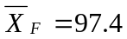.

The mean temperature in centigrade is 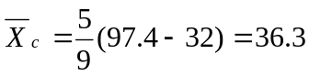.

Approximating the Mean from a Frequency Distribution

- possible only when the class mark can be assumed to be representative of all the values in that class. If the assumption holds, the following equation may be used to approximate the mean from a frequency distribution. 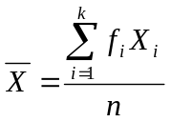

where f_{i} = the frequency of the ith class
X_{i} = the class mark of the ith class
k = total number of classes
n = total number of observations = 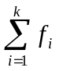

Example: Final grade of 110 Statistics 101 students

Class | Freq.  (f_{i}) | CM  (X_{I}) | f_{i}X_{i}
50 – 54  55 – 59  60 – 64  65 – 69  70 – 74  75 – 79  80 – 84  85 – 89  90 – 94  95 – 99 | 10  3  8  13  17  19  22  13  4  1 | 52  57  62  67  72  77  82  87  92  97 | 520  171  496  871  1224  1463  1804  1131  368  97
Total | 110 |  | 8145

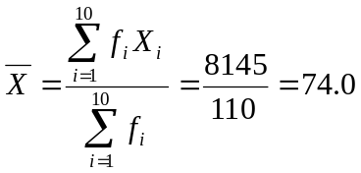

Remarks:

1. The formula for approximating the mean cannot be used if a frequency distribution has open-ended intervals, unless there are reasonably accurate estimates of the class marks for the open intervals.

2. The mean of a frequency distribution is simply a weighted mean of the class marks, where the f_{i}’s are the weights.
3.3 THE MEDIAN

- the positional middle of the arrayed data
- in an array, one-half of the values precede the median and one-half follow it

The first step in calculating the median, denoted as Md, is to arrange the data in an array.

Let X_{(i)} be the ith observation in the array, i = 1, 2, . . . , n.

If n is odd, the median position equals (n+1)/2, and the value of the (n+1)/2 th observation in the array is taken as the median, i.e.,

Md = X _{([n +1] / 2 )}

If n is even, the mean of the two middle values in the array is the median, i.e.,

Md = 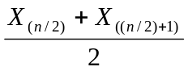

Examples :

1. Given the following heights ( in inches ): 71, 72, 75, 75, and 67 . Find the median height.

2. Given the following scores: 1, 7, 3, 3, 6, 5, 4, 3, find the median of the scores.

3. Refer to the example on the grades of 110 Statistics 101 students. The median is given by Md = 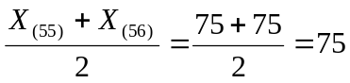.

Characteristics of the Median:

1. The median is a positional measure.

- The median is affected by the position of each item in the series but not by the value of each item. This means that extreme values affect the median less than the arithmetic mean.
Approximating the Median from the Frequency Distribution

- possible only when the values of the observations falling in the median class can be assumed to be evenly spaced throughout the class. (The median class is the class containing the median.)

Step 1. Construct the less than cumulative frequency distribution.
Step 2. Starting from the top, locate the class with less than cumulative frequency greater than or equal to n/2 for the first time. This class is the median class.
Step 3. Approximate the median using the following formula:

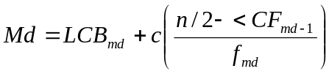

where LCB_{md} = the lower class boundary of the median class
c = class size of the median class
n = the total number of observations in the distribution
<CF _{md - 1} = less than cumulative freq. of the class preceding the median class
f_{md} = frequency of the median class

Example:

Refer to the example on the final grades of 110 Statistics 101 students.

Class | Freq. | <CF
Median class  < cum. freq. greater than n/2=55 for the first time  50 – 54  55 – 59  60 – 64  65 – 69  70 – 74  75 – 79  80 – 84  85 – 89  90 – 94  95 – 99 | 10  3  8  13  17  19  22  13  4  1 | 10  13  21  34  51  70  92  105  109  110

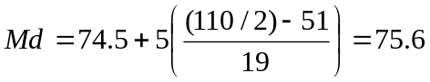

3.4 The Mode

- the observed value that occurs most frequently
- locates the point where the observation values occur with the greatest density
- generally a less popular measure than the mean or the median

The mode is determined by counting the frequency of each value and finding the value with the highest frequency of occurrence.

Examples:

1. 2, 5, 2, 3, 5, 2, 1, 4, 2, 2, 2, 1, 2, 2, 2, 3, 2, 2, 2, 2

2. 2, 5, 5, 2, 2, 5, 1, 3, 5, 4, 2, 5, 5, 2, 2, 5, 5, 2, 2, 1

3. 1, 2, 3, 3, 2, 1, 2, 3, 1, 4, 4, 5, 5, 1, 2, 3, 4, 5, 4, 5

4. Refer to the example on the final grades of 110 Statistics 101 students. The mode is Mo=84.

Characteristics of the Mode:

1. It does not always exist; and if it does, it may not be unique. A data set is said to be unimodal if there is only one mode, bimodal if there are two modes, trimodal if there are three modes, and so on.

2. It is not affected by extreme values.

3. The mode can be used for qualitative as well as quantitative data.

Approximating the Mode from the Frequency Distribution

Step 1: Locate the modal class. The modal class is the class with the highest frequency.
Step 2: Approximate the mode using the following formula:

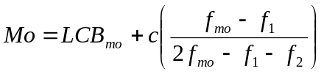

where LCB_{mo} = lower class boundary of the modal class
c = class size of the modal class
f_{mo} = frequency of the modal class
f₁ = frequency of the class preceding the modal class
f₂ = frequency of the class following the modal class

Example :

Refer to the example on the final grades of 110 Statistics 101 students.

Class | Freq.
Modal class  50 – 54  55 – 59  60 – 64  65 – 69  70 – 74  75 – 79  80 – 84  85 – 89  90 – 94  95 – 99 | 10  3  8  13  17  19  22  13  4  1

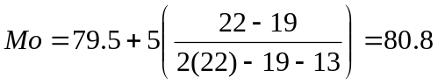

3.5 Measures of Location ( Fractiles )

Definition. Measures of location or fractiles are values below which a specified fraction or percentage of the observations in a given set must fall.

Definition. Percentiles are values that divide a set of observations in an array into 100 equal parts. Thus,

P₁, read as first percentile, is the value below which 1% of the values fall.

P₂, read as second percentile, is the value below which 2% of the values fall.
•
•
•
P₉₉, read as ninety-ninth percentile, is the value below which 99% of the values fall.

To compute for the ith percentile:

P_{i} = the value of the 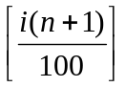th observation in the array

Approximating the ith Percentile from the Frequency Distribution

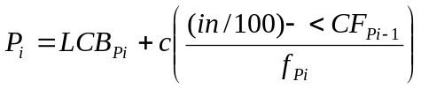

where LCB_{Pi} = the lower class boundary of the P_{i} th class
c = the class size of the P_{i}th class
n = the total number of observations in the distribution
<CF _{Pi - 1} = the less than cumulative frequency of the class preceding
the P_{i} th class
f_{Pi} = frequency of the P_{i} th class

The P_{i} th class is the class where the less than cumulative frequency is equal to, or exceeds for the first time, in/100.

Other Forms of Fractiles:

1. Deciles

- values that divide the array into 10 equal parts. Thus,

D₁, read as first decile, is the value below which 10% of the values fall.
D₂, read as second decile, is the value below which 20% of the values fall.
•
•
•
D₉, read as ninth decile, is the value below which 90% of the values fall.

2. Quartiles

- values that divide the array into 4 equal parts. Thus,

Q₁, read as first quartile, is the value below which 25% of the values fall.
Q₂, read as second quartile, is the value below which 50% of the values fall.
Q₃, read as third quartile, is the value below which 75% of the values fall.

CHAPTER 4

Measures of Dispersion
and
Measures of Skewness

Definition. Measures of dispersion indicate the extent to which individual items in a series are scattered about an average.

Some Uses for Measuring Dispersion

- to determine the extent of the scatter so that steps may be taken to control the existing variation

- used as a measure of reliability of the average value

General Classifications of Measures of Dispersion

1. Measures of Absolute Dispersion
2. Measures of Relative Dispersion

4.1 MEASURES OF ABSOLUTE DISPERSION

Measures of absolute dispersion are expressed in the units of the original observations. They can not be used to compare variations of two data sets when the averages of these data sets differ a lot in value or when the observations differ in units of measurement.

- The Range

Definition. The range of a set of measurements is the difference between the largest and the smallest values.

Range = maximum - minimum

The range is approximated from a frequency distribution by getting the difference between the upper class limit of the highest class interval and the lower class limit of the lower class interval.

Examples:

1. The IQ’s of 5 members of a certain family are 108, 112, 127, 116, and 113. Find the range.

2. Refer to the example on the final grade of 110 Statistics 101 students. The range is Range = 96 – 50 = 46.

Approximating the range from the frequency distribution table, we get
Range = 99 – 50 = 49.

Characteristics of the Range

1. It uses only the extreme values. It fails to communicate any information about the clustering or the lack of clustering of the values between the extremes.

2. A weakness of the range is that an outlier can greatly alter its value.

3. It can not be approximated from open-ended frequency distributions.

4. It is unreliable when computed from a frequency distribution table with gaps or zero frequencies.

- The Standard Deviation and the Variance

Definition. For a finite population of size N, the population variance is

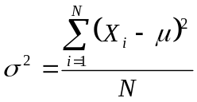

and the population standard deviation is

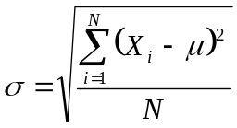

Definition. For a sample of size n, the sample variance is

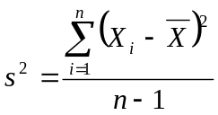

and the sample standard deviation is

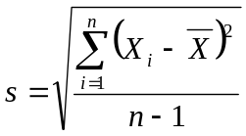

Remarks:

1. The standard deviation is the most frequently used measure of dispersion.

2. The variance is not a measure of absolute dispersion. It is not expressed in the same units as the original observations.

Examples:

1. The following scores were given by 6 judges for a gymnast’s performance in the vault: 7, 5, 9, 7, 8, and 6. Find the standard deviation.

μ = 7 σ = 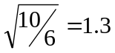

2. A sample of 5 households showed the following number of household members: 3, 8, 5, 4, and 4. Find the standard deviation.

= 4.8 s = 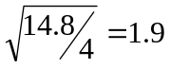

- Refer to the example on the final grades of 110 Statistics 101 students. The sample standard deviation is given by

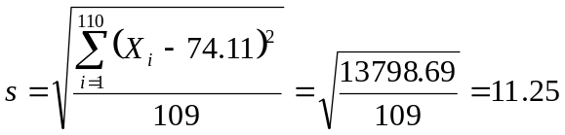

Computational formula:

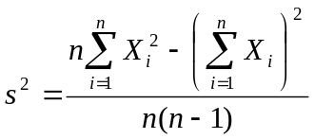

Example: the final grade of 110 Statistics 101 students,

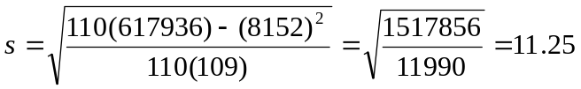

Approximating the Variance from the Frequency Distribution

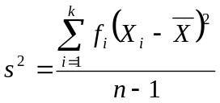

or, using the computational formula,

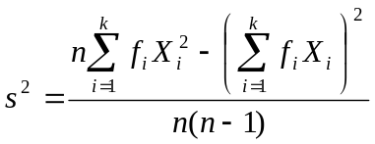

where f_{i} = frequency of the i^{th} class
X_{i} = classmark of the i^{th} class
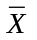 = mean of the frequency distribution
n = total number of observations

Example:

Class | Freq.  (f_{i}) | CM  (X_{i}) | f_{i}X_{i} | f_{i}X_{i}²
50 – 54  55 – 59  60 – 64  65 – 69  70 – 74  75 – 79  80 – 84  85 – 89  90 – 94  95 – 99 | 10  3  8  13  17  19  22  13  4  1 | 52  57  62  67  72  77  82  87  92  97 | 520  171  496  871  1224  1463  1804  1131  368  97 | 27040  9747  30752  58357  88128  112651  147928  98397  33856  9409
Total | 110 |  | 8145 | 616265

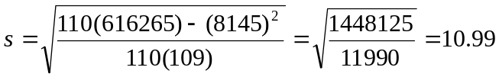

Characteristics of the Standard Deviation

1. It is affected by the value of every observation. It may be distorted by few extreme values.

2. It can not be computed from an open-ended distribution.

3. If each observation of a set of data is transformed to a new set by the addition (or subtraction) of a constant c, the standard deviation of the new set of data is the same as the standard deviation of the original data set.

4. If a set of data is transformed to a new set by multiplying (or dividing) each observation by a constant c, the standard deviation of the new data set is equal to the standard deviation of the original data set multiplied (or divided) by c.

4.2 MEASURES OF RELATIVE DISPERSION

Measures of relative dispersion are unitless and are used when one wishes to compare the scatter of one distribution with another distribution.

- The Coefficient of Variation

Definition. The coefficient of variation, CV, is the ratio of the standard deviation to the mean and is usually expressed in percentage. It is computed as

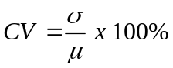

and its sample counterpart is

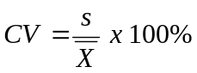

Examples.

1. The foreign exchange rate is an indicator of the stability of the peso and is also an indicator of the economic performance. In 1992 Bangko Sentral ng Pilipians (BSP) put the peso on a floating rate basis. Market forces and not government policy have determined the level of the peso since. Government intervenes through the BSP, only when there are speculative elements in the market. Given below are the means and standard deviations of the quarterly P-$ exchange rate for the periods 1989 to 1991 and 1992 to 1994. Which of the two periods is more stable?

Mean s.d.

1989-1991 22.4 1.84
1992-1994 26.4 1.15

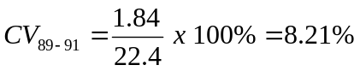
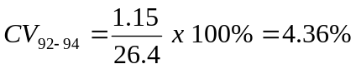
2. Two of the quality criteria in processing butter cookies are the weight and color development in the final stages of oven browning. Individual pieces of cookies are scanned by a spectrophotometer calibrated to reflect yellow-brown light. The readout is expressed in per cent of a standard yellow-brown reference plate and a value of 41 is considered optimal (golden-yellow). The cookies were also weighed in grams at this stage. The means and standard deviations of 30 sample cookies are presented below.

Mean s.d.

Color 41.1 10
Weight 17.7 3.2

Which of the two quality criteria is more varied?



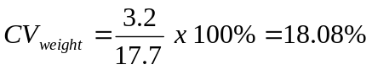

- The Standard Score

Definition. The standard score measures how many standard deviations an observation is above or below the mean. It is computed as

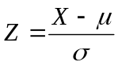

and the sample counterpart is

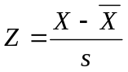

Remarks:

1. The standard score is not a measure of relative dispersion per se but is somewhat related.

- It is useful for comparing two values from different series specially when these two series differ with respect to the mean or standard deviation or both are expressed in different units.
Examples:

1. Robert got a grade of 75% in Stat 101 and a grade of 90% in Econ 11. The mean grade in Stat 101 is 70% and the standard deviation is 10%, whereas in Econ 11, the mean grade is 80% and the standard deviation is 20%. Relative to the other students, where did he perform better?

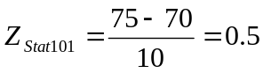
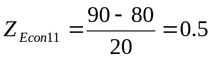

2. In problem (1), if the mean grade in Stat 101 is 65%, in which subject did Robert perform better?

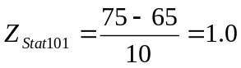

3. Different typing skills are required for secretaries depending on whether one is working in a law office, an accounting firm, or for a mathematical research group at a major university. In order to evaluate candidates for these positions, an agency administers 3 distinct standardized typing samples. A time penalty has been incorporated into the scoring of each sample based on the number of typing errors. The mean and standard deviation for each test, together with the scores achieved by Nancy, an applicant, are given in the following table.

Sample Nancy’s Score Mean std. dev.

Law 141 sec 180 sec 30 sec
Accounting 7 min 10 min 2 min
Scientific 33 min 26 min 5 min

Where do you think should Nancy be placed?

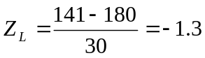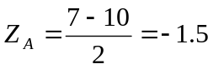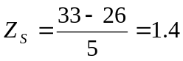

4.3 MEASURES OF SKEWNESS

Definition. A measure of skewness shows the degree of asymmetry, or departure from symmetry of a distribution. It indicates not only the amount of skewness but also the direction.

Two Type of Skewness

1. Positively Skewed or Skewed to the Right

- distribution tapers more to the right than to the left
- longer tail to the right
- more concentration of values below than above the mean
- most skewed curves encountered in the social sciences are skewed to the right

Example: frequency distribution of income

2. Negatively Skewed or Skewed to the Left

- distribution tapers more to the left than to the right
- longer tail to the left
- more concentration of values above than below the mean
- only rarely do we find curves skewed to the left, and even more rarely do we find data characteristically skewed to the left

Example: the distribution of ages at death of the American inventors may be characteristically skewed to the left, since younger men do not often have enough inventions to their credit to be classified as “inventor”

Pearson’s First and Second Coefficients of Skewness

1. 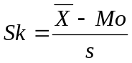

where = mean
Mo = mode
s = standard deviation

2. 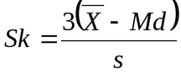

where = mean
Md = median
s = standard deviation

Remarks:

1. Since the mode is frequently only an approximation, formula 2 is preferred.

- Interpretation of the measure of skewness:

Sk > 0: positively skewed since > Md > Mo
Sk < 0: negatively skewed since < Md < Mo
Sk = 0: symmetric since = Md = Mo

Example: Refer to the final grade of 110 Statistics 101 students

= 74.1 Md = 75 Mo = 84 s = 11.25

Using the first formula,
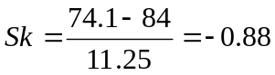

Using the second formula,

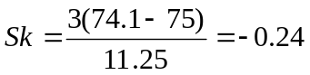

4.4 THE BOXPLOT

Definition. The boxplot is a graph that is very useful for displaying the following features of the data:

- location
- spread
- symmetry
- extremes
- outliers

Steps in Constructing a Boxplot

1. Construct a rectangle with one end at the first quartile and the other end at the third quartile.

2. Put a vertical line across the interior of the rectangle at the median.

3. Compute for the interquartile range (IQR), lower fence (F_{L}) and upper fence (F_{U}) given by:

IQR = Q₃ - Q₁
F_{L} = Q₁ - 1.5 IQR
F_{U} = Q₃ + 1.5 IQR

4. Locate the smallest value contained in the interval [F_{L} , Q₁]. Draw a line from this value to Q₁.

5. Locate the largest value contained in the interval [Q₃,F_{U}]. Draw a line from this value to Q₃.

6. Values falling outside the fences are considered outliers and are usually denoted by “x”.

Remarks:

1. The height of the rectangle is usually arbitrary and has no specific meaning. If several boxplots appear together, however, the height is sometimes made proportional to the different sample sizes.

2. If the outlying observation is less than Q₁ - 3 IQR or greater than Q₃ + 3 IQR it is identified with a circle at their actual location. Such an observation is called a far outlier.

Examples:

1. Set A: 1 15 21 22 24
10 18 22 23 25
14 20 22 24 28

Q₁ = 15 IQR = 9
Q₃ = 24 F_{L} = 1.5
Md = 22 F_{U} = 37.5

Set B: 3 10 11 12 19
8 10 11 16 19
9 10 12 16 30

Q₁ = 10 IQR = 6
Q₃ = 16 F_{L} = 1
Md = 12 F_{U} = 25

Set A x

Set B x

0 5 10 15 20 25 30 35

2. Boxplot of the final grade of 110 Statistics 101 students.

50 55 60 65 70 75 80 85 90 95 100
p

CHAPTER 5

Probability

5.1 Random Experiments, Sample Spaces and Events

Definition of Terms

- Random experiment any process of generating a set of data or observations that can be repeated under basically the same conditions, which lead to well-defined outcomes

- Sample space set of all possible outcomes of an experiment, usually denoted by S

- Sample point an element of the sample space, an outcome

- Event any subset of the sample space, usually denoted by capital letters

- Null space/Empty space a subset of the sample space that contains no elements and denoted by the symbol φ.

- Simple event an event which contains only one element of the sample space

- Compound event an event that can be expressed as the union of simple events, thus containing more than one sample point

- Mutually exclusive events Two events A and B are mutually exclusive if A∩B=φ; that is, A and B have no elements in common

Remarks:

- An event is said to have occurred if the outcome of the experiment is one of the sample points in the event.

- The empty space can be viewed as an event that will never happen. It is called the impossible event.

- The sample space S, as an event, always occurs, and is referred to as the certain or sure event.

Event Composition and Event Relations

- A ∩ B the intersection of events A and B is the event that both A and B occur

- A U B the union of events A and B is the event that A or B or both occur

- A¹ or A^{c} the complement of an event A with respect to S contains all elements of S that are not in A and is the event that A does not occur

Some relationships between events can be illustrated by means of a Venn Diagram.

5.2 THE PROBABILITY CONCEPT AND SOME PROPERTIES

Definition. The probability of an event A, denoted by P(A), is the sum of the probabilities of mutually exclusive outcomes that constitute the event. It must satisfy the following properties:

- 0 ≤ P(A) ≤ 1 for any event A
- P(S) = 1 where S is the sample space
- P(φ) = 0

Approaches to Assigning Probabilities

1. A Priori or Classical Probability – probability is determined even before the experiment is performed using the following rule:

If an experiment can result in any one of N different equally likely outcomes, and if exactly n of these outcomes correspond to event A, then the probability of event A is

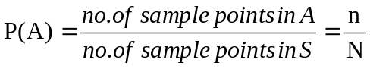

2. A Posteriori or Relative Frequency or Empirical Probability - probability is determined by repeating the experiment a large number of times using the following rule:
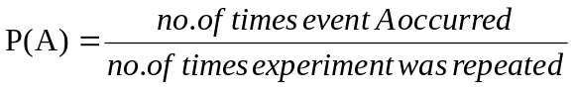
3. Subjective Probability – probability is determined by the use of intuition, personal beliefs, and other indirect information.
Examples:

1. Find the errors in each of the following statements:

a. The probability that it will rain tomorrow is 0.40 and the probability that it will not rain tomorrow is 0.52.

- The probabilities that a printer will make 0, 1, 2, 3, or 4 or more mistakes in printing a document are, respectively, 0.19, 0.34, -0.25, 0.43, and 0.29.

c. The probabilities that an automobile salesperson will sell 0, 1, 2, or 3 cars on any given day in February are, respectively, 0.19, 0.38, 0.29, and 0.15.

d. On a single draw from a deck of playing cards the probability of selecting a heart is 1/4, the probability of selecting a black card is 1/2, and the probability of selecting both a heart and a black card is 1/8.

2. a. In tossing a fair coin, what is the probability of getting a head? Of either a head or tail? Of neither a head nor tail?
b. In tossing a fair die, what is the probability of getting a 3? Of getting an even number? Of getting a number greater than 6?

3. A coin is biased so that a head is twice as likely to occur as a tail. If the coin is tossed once, what is the probability of getting a head?

Rules of Counting (Optional)

Theorem. If an operation can be performed in n₁ ways, and for each of these a second operation can be performed in n₂ ways, then the two operations can be performed in n₁n₂ ways.

Example: How many sample points are there in the sample space when a pair of balanced dice is thrown once?

Theorem. (Multiplication Rule) If an operation can be performed in n₁ ways, if for each of these a second operation can be performed in n₂ ways, if for each of the first two a third operation can be performed in n₃ ways, and so on, then the sequence of k operations can be performed in n₁n₂ ... n_{k} ways.

Examples:

1. How many even three-digit numbers can be formed from the digits 1, 2, 5, 6, and 9 if each digit can be used only once?

2. How many ways can a 10-question true-false examination be answered?
Definition. A permutation is an arrangement or ordering of all or part of a set of objects.

Theorem. The number of permutations of n distinct objects is

n (n-1)(n-2) . . . (2)(1) = n!

(n! is read “n factorial”)

Note. 0! = 1.

Example: How many different orders or sequences can we arrange the letters A, B, C, and D?

Theorem. The number of permutations of n distinct objects taken r at a time is
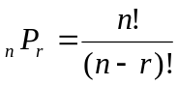

Examples:

1. Two lottery tickets are drawn from 20 for the first and second prize. Find the number of sample points in the space S.

2. In how many ways can the 5 starting positions on a basketball team be filled with 8 men who can play any position?

Theorem. The number of distinct permutations of n things of which n₁ are of one kind, n₂ are of a second kind, . . . , n_{k} of a k^{th} kind is

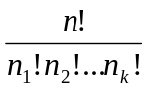 where 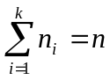

Examples:

1. Consider our favorite word, STATISTICS, that contains a total of 10 letters. There are 3 classes of indistinguishable objects that consists of 3 S’s, 3 T’s and 2 I’s. Find the total number of distinct permutations of these 10 letters.

2. In how many different ways can 3 red, 4 yellow, and 2 blue bulbs be arranged in a string of Christmas tree lights with 9 sockets?
Definition. A combination is a selection of r objects from n without regard to order.

Theorem. The number of combinations of n distinct objects taken r at a time is
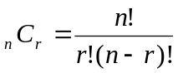

Examples:

1. In a Stat 101 exam, a student has a choice of 8 questions out of 10. In how many ways can he choose a set of 8 questions if he chooses arbitrarily?

2. Find the number of ways of selecting the 6 winning numbers in the original version of the game of lotto.

Theorems on Probabilities of Events

Theorem. (Additive Rule) If A and B are any two events, then

P(A∪B) = P(A) + P(B) - P(A∩B)

Corollary. If A and B are mutually exclusive, then
P(A∪B) = P(A) + P(B)

Corollary. If A₁, A₂, . . . , A_{n} are mutually exclusive, then
P(A₁ ∪ A₂ ∪ . . . ∪ A_{n}) = P(A₁) + P(A₂) + . . . +P(A_{n})

Theorem. If A and A^{c} are complementary events, then

P(A) + P(A^{c}) = 1.
Examples:

1. The probability that a student passes Stat 101 is 0.60, and the probability that he passes Comm II is 0.85. If the probability that he passes at least one of the two courses is 0.95, what is the probability that he will pass both courses? fail both Stat 101 and Comm II?

- An oil-prospecting firm plans to drill two exploratory wells. Past evidence shows that the probability that neither well produces oil is 0.8; the probability that exactly one well produces oil is 0.18; and, the probability that both wells produce oil is 0.02. What is the probability that at most one well produces oil? At least one?

3. In the toss of a fair coin 4 times, what is the probability of no head in the toss? At least one head?

Definition. The probability of an event B occurring when it is known that some event A has occurred is called a conditional probability. It is defined by the equation
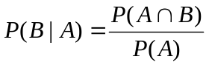 if P(A)>0

P(B⏐A) is read as “probability of B given A”.

Examples:

1. A random sample of 100 insurance claims are classified below according to the type of policy and whether the claim is fraudulent or not.

a. Find the probability of a fraudulent claim given that such a claim is for a fire policy.

b. Find the probability that a claim for a fire policy is selected given that such a claim is fraudulent.

Categorization of Insurance Claims

Category | Type of Policy |  |  | Total
Category | Fire | Auto | Others | Total
Fraudulent | 6 | 1 | 3 | 10
Nonfraudulent | 14 | 29 | 47 | 90
Total | 20 | 30 | 50 | 100

2. The probability that a student passes Stat 101 is 0.60, the probability that he passes Comm II is 0.85, the probability that he passes both subjects is 0.5. If the student passes Stat 101, what is the probability that the student will pass Comm II?

Definition. Two events A and B are said to be independent if any one of the following conditions is satisfied:

(a) P(A⏐B) = P(A) if P(B)>0
(b) P(B⏐A) = P(B) if P(A)>0
(c) P(A∩B) = P(A) P(B)

Otherwise, the events are said to be dependent.

Examples:

1. The probability that Robert will correctly answer the toughest question in an exam is 1/4. The probability that Ana will correctly answer the same question is 4/5. Find the probability that both will answer the question correctly, assuming that they do not copy from each other.

2. Consider the following events in the toss of a single die:

A: Observe an odd number
B: Observe an even number

Are A and B independent events?

CHAPTER 6

Probability Distributions

6.1 CONCEPT OF A RANDOM VARIABLE

Definition. A function whose value is a real number determined by each element in the sample space is called a random variable.

Remark. We shall use an uppercase letter, say X, to denote a random variable and its corresponding lowercase letter, x in this case, for one of its values.

Examples:

1. (Experiment No. 1) An experiment consists of tossing a coin 3 times and observing the result. The possible outcomes and the values of the random variables X and Y, where X is the number of heads and Y is the number of heads minus the number of tails are

Sample Points x y

HHH 3 3
HHT 2 1
HTH 2 1
HTT 1 -1
THH 2 1
THT 1 -1
TTH 1 -1
TTT 0 -3

2. (Experiment No. 2) A hatcheck girl returns 3 hats at random to 3 customers who had previously checked them. If Jason, Charlie, and Ohmar, in that order, receives one of the hats, list the sample points for the possible orders of returning the hats and find the values m of the random variable M, that represents the number of correct matches.

6.2 DISCRETE & CONTINUOUS PROBABILITY DISTRIBUTIONS

Definition. If a sample space contains a finite number of possibilities or an unending sequence with as many elements as there are whole numbers, it is called a discrete sample space.

Definition. A random variable defined over a discrete sample space is called a discrete random variable.

Definition. If a sample space contains an infinite number of possibilities equal to the number of points on a line segment, it is called a continuous sample space.

Definition. A random variable defined over a continuous sample space is called a continuous random variable.

Discrete Probability Distributions

Definition. A table or formula listing all possible values that a discrete random variable can take on, along with the associated probabilities, is called a discrete probability distribution.

Remark. The probabilities associated with all possible values of a discrete random variable must sum to 1.

Examples:

1. For Experiment No. 1, the discrete probability distributions of the random variables X and Y are

x | 0 | 1 | 2 | 3
P(X=x) | 1/8 | 3/8 | 3/8 | 1/8

y | -3 | -1 | 1 | 3
P(Y=y) | 1/8 | 3/8 | 3/8 | 1/8

2. Construct the discrete probability distribution for the random variable M defined in Experiment No. 2.

Continuous Probability Distributions

Definition. The function with values f(x) is called a probability density function for the continuous random variable X, if

- the total area under its curve and above the horizontal axis is equal to 1; and
- the area under the curve between any two ordinates x = a and x = b gives the probability that X lies between a and b.

Remarks:

1. A continuous random variable has a probability of zero of assuming exactly any of its values, that is, if X is a continuous random variable, then P(X=x) = 0 for all real numbers x.

2. The probability density function can not be represented in tabular form.

Example:

A continuous random variable X that can assume values between 0 and 2 has a density function given by

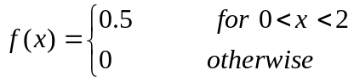

Find the following probabilities:

a. P(1 < X < 2).

f(x)
1/2

0 1 2

area of shaded region = (length)(width)

P(1 < X < 2) = (1/2)(1) =1/2

- P(X > 1.5)
- P(X < 0.75)
- P(X = 0.75)
- P(X ≤ 0.75).

6.3 EXPECTED VALUES

Definition. Let X be a discrete random variable with probability distribution

x | x₁ | x₂ | . . . | x_{n}
P(X=x) | f(x₁) | f(x₂) | . . . | f(x_{n})

The mean or expected value of X is
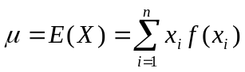

Examples:

1. Find the mean of the random variables X and Y of Experiment No. 1.

X | 0 | 1 | 2 | 3
P(X=x) | 1/8 | 3/8 | 3/8 | 1/8

E(X) = (0)(1/8) + (1)(3/8) + (2)(3/8) + (3)(1/8) = 12/8 or 1.5

Y | -3 | -1 | 1 | 3
P(Y=y) | 1/8 | 3/8 | 3/8 | 1/8

E(Y) = (-3)(1/8) + (-1)(3/8) + (1)(3/8) + (3)(1/8) = 0

2. Find the expected number of correct matches in Experiment No. 2.

3. In a gambling game a man is paid P50 if he gets all heads or all tails when 3 coins are tossed, and he pays out P30 if either 1 or 2 heads show. What is his expected gain?

Theorem. Let X be a discrete random variable with probability distribution

x | x₁ | x₂ | . . . | x_{n}
P(X=x) | f(x₁) | f(x₂) | . . . | f(x_{n})

The mean or expected value of the random variable g(X) is
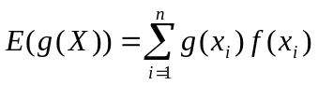
Example: A used car dealer finds that in any day, the probability of selling no car is 0.4, one car is 0.2, two cars is 0.15, 3 cars is 0.10, 4 cars is 0.08, five cars is 0.06 and six cars is 0.01. Let g(X) = 500 + 1500X represent the salesman’s daily earnings, where X is the number of cars sold. Find the salesman’s expected daily earnings.

Definition. Let X be a random variable with mean μ then the variance of X is

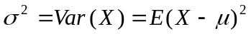

Definition. Let X be a discrete random variable with probability distribution

X | x₁ | x₂ | . . . | x_{n}
P(X=x) | f(x₁) | f(x₂) | . . . | f(x_{n})

The variance of X is

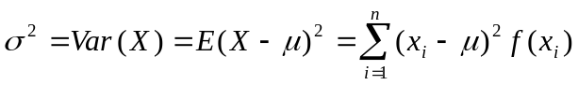

Theorem. Computational Formula for σ²

Var(X) = E(X²) - [E(X)]²

Example :

In Experiment No. 1, find the variance of X.

Using the definition of Var(X),

E(X) = 1.5
Var(X) = 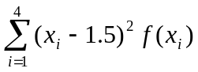
= (0-1.5)²(1/8) + (1-1.5)²(3/8) + (2-1.5)²(3/8) + (3-1.5)²(1/8) = 0.75

Using the computational formula of the Var(X),

Var(X) = E(X²) - [E(X)]²

= 3 – (1.5)² = 0.75
Properties of the Mean and Variance

Let X and Y be random variables (discrete or continuous) and let a and b be constants.

1. E(aX + b) = a E(X) + b

Special Cases:
a. if b = 0, then E(aX) = a E(X).
b. if a = 0, then E(b) = b.

- E(X+Y) = E(X) + E(Y)
E(X-Y) = E(X) - E(Y)

3. E(XY) = E(X)E(Y) if X and Y are independent.

4. E[ X - E(X) ] = 0.

5. Var(aX + b) = a²Var(X).

Special Cases:
a. if b = 0, then Var(aX) = a²Var(X).
b. if a = 0, then Var(b) = 0.

- If X and Y are independent then
Var(X + Y) = Var(X) + Var(Y)
Var(X - Y) = Var(X) + Var(Y)

Example :

If X and Y are independent random variables with E(X) = 3, E(Y) = 2, Var(X) = 2 and Var(Y)=1, find

- E(3X + 5)
- Var(3X +5)
c. E(XY)
d. Var(3X - 2Y)

6.4 The Normal Distribution

Definition. A continuous random variable X is said to be normally distributed if its density function is given by :
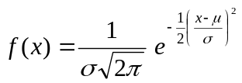

for -∞ < x < ∞ and for constants μ and σ, where -∞ < μ < ∞ , σ>0 and e≈2.71828 and π ≈ 3.14159.

Notation: If X follows the above distribution, we write X~ N(μ, σ² ).
Note: If X~ N(μ, σ² ), then

E(X)=μ and Var (X) = σ².

The graph of the normal distribution is called the normal curve.

μ

Properties:

1. The curve is bell-shaped and symmetric about a vertical axis through the mean μ.

2. The normal curve approaches the horizontal axis asymptotically as we proceed in either direction away from the mean.

3. The total area under the curve and above the horizontal axis is equal to 1.

Definition. The distribution of a normal random variable with mean zero and standard deviation equal to 1 is called a standard normal distribution.

If X~ N(μ, σ² ) , then X can be transformed into a standard normal random variable through the following transformation,

Hence, whenever X is between the values x₁ and x₂, the random variable Z will fall between the corresponding values

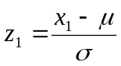 and 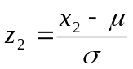

Thus, P ( x₁ < X < x₂ ) = P ( z₁ < Z < z₂ ) .

Examples :

1. Given a normal distribution with μ = 40 and σ = 8, find the probability that X assumes a value
a. less than 45
b. between 35 and 45
c. more than 45

2. Given the normally distributed random variable X with mean 18 and standard deviation 2.5, find

a. the value k such that P( X< k) = 0.2578
b. the value k such that P( X> k) = 0.1539.

3. The achievement scores for a college entrance examination are normally distributed with mean 75 and standard deviation equal to 10. What fraction of the scores would one expect to lie between 70 and 90?

4. A softdrink machine is regulated so that it dispenses an average of 200 ml. per cup. If the amount of drink dispensed is normally distributed with a standard deviation equal to 15 ml.,

a. what fraction of the cups will contain more than 224 ml ?
b. what is the probability that a cup contains between 191 ml. and 209 ml. ?
c. how many cups will likely overflow if 230 ml. cups are used for the next 1000 drinks ?
d. below what value do we get the smallest 25% of the drinks?
6.5 OTHER COMMON DISTRIBUTIONS

- Binomial Distribution

Definition. A binomial experiment is one that possesses the following properties:

- the experiment consists of n identical trials
- each trial results in one of two outcomes, a “success” or a “failure”
- the probability of success on a single trial is equal to p and remains the same from trial to trial. The probability of a failure is equal to q=1-p.
- the trials are independent

The random variable of interest X, the number of successes observed in n trials, is called a binomial random variable.

Definition. The discrete probability distribution of the binomial random variable is given by
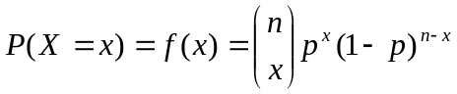, x = 0,1,…,n and 0<p<1

Notation : If X follows the above distribution, we will write X~Bi(n, p).

Note : If X~Bi(n, p) then E(X) = np and Var(X) = npq, where q = 1-p.

Examples:

1. A multiple-choice quiz has 15 questions, each with 4 possible answers of which only 1 is the correct answer. What is the probability that sheer guesswork yields

a. exactly 10 correct answers
b. at least 1 correct answer
c. 8 to 12 correct answers .

2. Suppose that airplane engines operate independently in flight and fail with probability 1/5. Assuming that a plane makes a safe flight if at least one-half of its engines run, which between a 4-engine plane and a 2-engine plane has the higher probability for a successful flight?

- Hypergeometric Distribution (Optional)

Definition. A hypergeometric experiment is one that possesses the following properties:

- a sample of size n is taken without replacement from a population of size N
- k of the N are classified as “success” and (N-k) classified as “failure”.

The random variable of interest X, the number of successes in the sample, is called a hypergeometric random variable.

Definition. The discrete probability distribution of the hypergeometric random variable is given by
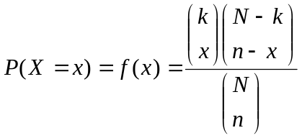, x = 0,1,…, min(n,k)

Notation: If X follows the above distribution, we write X~H(N,n,k).

Note: If X~H(N,n,k) then
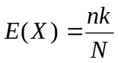 and 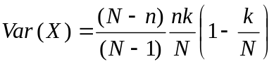

Remark: If n is small relative to N the probability of “success” for each draw will change only slightly. Hence, the hypergeometric distribution can be approximated by the binomial distribution with p = k/N.

Examples:

1. What is the probability that a person’s 6 number bet wins the second prize in a game of lotto?

2. A lot of 20 personal computers was delivered to the Statistical Center. Ten computers were selected at random without replacement and tested for defects. If at least 2 of these 10 are defective, the entire lot of 20 computers will be returned. What is the probability that the lot will be returned if 5 of the 20 computers are indeed defective?

3. A production lot of 2000 units contains 50 units that do not meet the specifications. What is the probability that a random sample of 20 units without replacement will contain no nonconforming item?
- Poisson Distribution (Optional)

Definition. A poisson experiment is one that possesses the following properties:

- the number of outcomes occurring in one time interval or specified region is independent of the number that occur in any other disjoint time interval or region of space
- the probability that a single outcome will occur during a very short time interval or in a small region is proportional to the length of the time interval
- the probability that more than one outcome will occur in such a short time interval or fall in such a small region is negligible

The random variable of interest X, the number of outcomes in a specified length of time interval or region, is called a Poisson random variable.

Definition. The probability distribution of the Poisson random variable is given by

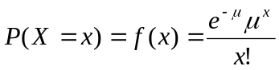, x = 0,1,2,….

Notation: If X follows the above distribution, we write X~Poi(μ).

Note: If X~Poi(μ), then E(X) = μ and Var(X) = μ.

Remark: If X~Bi(n, p) and n is large and p is close to 0, the Poisson distribution is used to approximate the Binomial distribution with μ = np.

Examples:

1. On the average a certain intersection results in 3 traffic accidents per month. Suppose that the number of accidents per month follows a Poisson distribution, what is the probability that in any given month at this intersection,

a. exactly 5 accidents will occur?
b. less than 3 accidents will occur?
c. at least 2 accidents will occur?

2. The probability that a person dies from a certain respiratory infection is 0.002. Find the probability that fewer than 5 in a random sample of 2000 so infected will die.

- Normal Approximation (Optional)

Normal Approximation to the Binomial

Theorem. If X~Bi(n, p) with mean np and variance npq, then the distribution of

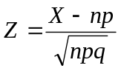

as n approaches ∞ will approximate the standard normal distribution.

Remarks:

1. The normal distribution gives a very good approximation of the Binomial distribution when n is large and p is close to 1/2.

2. Since a continuous distribution (in this case, the Normal) is used to approximate a discrete distribution, then we must adjust for continuity. For example:

Let X~Bi(n, p).

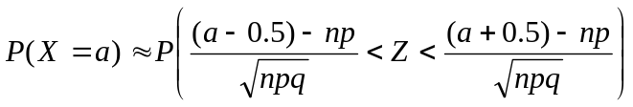

Example:

A certain pharmaceutical company knows that, on the average, 45% of a certain type of pill has an ingredient that is below the minimum strength and thus unacceptable. What is the probability that fewer than 10 in a sample of 200 pills will be unacceptable?

CHAPTER 7

Sampling Distributions

Definition. The probability distribution function of a statistic is called its sampling distribution.

- A statistic (e.g. sample mean, sample standard deviation) is a random variable whose value depends only on the observed sample and may vary from sample to sample.

- The sampling distribution of a statistic will depend on the size of the population, the size of the sample, and the method of choosing the sample.

- The standard deviation of the sampling distribution is called the standard error of the statistic. It tells us the extent to which we expect the values of the statistic to vary from different possible samples.

- The probability distribution of the sample mean is called the sampling distribution of the mean.

Sampling Distribution of the Mean

Consider 4 observations making up the population values of a random variable X having the probability distribution

f(x) = 1/ 4 , x = 0, 1, 2, 3

Note that μ = E(X) = 3/2 and σ² = Var(X) = 5/4 .

Suppose we list all possible samples of size 2, with replacement, and for each sample compute for the value of the sample mean, :

No. Sample 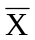 | No. Sample
1 0, 0 0.0  2 0, 1 0.5  3 0, 2 1.0  4 0, 3 1.5  5 1, 0 0.5  6 1, 1 1.0  7 1, 2 1.5  8 1, 3 2.0 | 9 2, 0 1.0  10 2, 1 1.5  11 2, 2 2.0  12 2, 3 2.5  13 3, 0 1.5  14 3, 1 2.0  15 3, 2 2.5  16 3, 3 3.0

Sampling Distribution of the Mean

 | f()
0 | 1/16
0.5 | 2/16
1.0 | 3/16
1.5 | 4/16
2.0 | 3/16
2.5  3.0 | 2/16  1/16

Note : E( ) = 3/2 and Var() = 5/8.

Theorems:

- If all possible random samples of size n are drawn with replacement from a finite population of size N with mean μ and standard deviation σ, then the sample mean will have mean and variance given by:

E() = μ and Var() = σ² /n .

- If all possible random samples of size n are drawn without replacement from a finite population of size N with mean μ and standard deviation σ, then the sample mean will have mean and variance given by:

E( ) = μ and Var() = 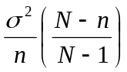.

- The factor 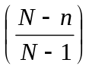 in the formula of the variance of is called the finite population correction factor. For large N relative to the sample size n, this factor will be close to 1 and the variance of is approximately equal to σ² /n.

3. Central Limit Theorem

If is the mean of a random sample of size n taken from a (large or infinite) population with mean μ and variance σ², then the sampling distribution of is approximately normally distributed with mean E()=μ and variance Var()=σ²/n when n is sufficiently large. Hence, the limiting form of the distribution of

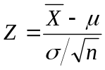

as n approaches infinity is the standard normal distribution.

- The normal approximation in the theorem will be good if n ≥ 30 regardless of the shape of the population.

- If n < 30, the approximation is good only if the population is not too different from the normal.

- If the distribution of the population is normal then the sampling distribution will also be exactly normal, no matter how small the size of the sample.

Example:

An electrical firm manufactures electric light bulbs that have a length of life which is normally distributed with mean and standard deviation equal to 500 and 50 hours, respectively. Find the probability that a random sample of 15 bulbs will have an average life of less than 475 hours.

4. The t-distribution.

If and S² are the mean and variance, respectively, of a random sample of size n taken from a population which is normally distributed with mean μ and variance σ² , then

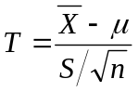
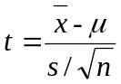
is a random variable having the t - distribution with v = n-1 degrees of freedom.

- Notation: T~ t_{v=n-1}

- Comparison between the t-distribution and the standard normal distribution

1. Both are symmetric about zero
2. Both are bell-shaped, but the t-distribution is more variable

(i) t-values depend on the fluctuation of 2 quantities: and S²
(ii) z-values depend only on the changes in from sample to sample

3. When the sample size is large, i.e. n ≥ 30, the t-distribution can be well approximated by the standard normal distribution.

- Area under the curve

Just like any continuous probability distribution, the probability that a random sample produces a t-value falling between any two specified values is equal to the area under the curve of the t-distribution between any two ordinates corresponding to the specified values

- Notation: t_{α} is the t-value leaving an area of α in the right-tail of the t-distribution. That is, if T~t_{(v)} then t_{α} is such that P(T> t_{α}) ₌ α.

- Since the t-distribution is symmetric about zero, t_{1-α} = - t_{α}

Examples:

1. Find the following values on the t -table:
(a) t_{0.025} when v = 14.
(b) t_{0.99} when v=10.

2. Find k such that P(k < T < 2.807) = 0.945 when T ~ t₍₂₃₎

- A manufacturing firm claims that the batteries used in their electronic games will last an average of 30 hours. To maintain this average, 16 batteries are tested each month. If the computed t-value falls between -t_{0.025} and t_{0.025} , the firm is satisfied with its claim. What conclusion should the firm draw from a sample that has mean = 27.5 hours and standard deviation S = 5 hours? Assume the distribution of battery lives to be approximately normal.
CHAPTER 8

Estimation

Definition. Statistical inference refers to methods by which one uses sample information to make inferences or generalizations about a population.

Two Areas of Statistical Inference

- Estimation
- point estimation
- interval estimation

2. Hypothesis Testing

8.1 BASIC CONCEPTS IN ESTIMATION

Point Estimation

Definition. An estimator is any statistic whose value is used to estimate an unknown parameter. A realized value of an estimator is called an estimate.

For example, the sample mean , is an estimator of the population mean μ.

Remarks:

1. An estimator is said to be unbiased if the average of the estimates it produces under repeated sampling is equal to the true value of the parameter being estimated.

Examples: Under random sampling, the sample mean is an unbiased estimator of the population mean, that is, E() = μ.

Under random sampling with replacement, S² is an unbiased estimator of σ², but S on the other hand is a biased estimator of σ with the bias becoming insignificant for large samples.

2. A parameter can have more than one unbiased estimator. We would naturally choose the unbiased estimator with the smallest variance.

Interval Estimation

Definition. An interval estimator of a population parameter is a rule that tells us how to calculate two numbers based on sample data, forming an interval within which the parameter is expected to lie. This pair of numbers, (a,b), is called an interval estimate or confidence interval.

Example. The running time (in minutes) of a sample of films produced by Star-Regal Theater are as follows: 103 94 110 87 98.

A 95% confidence interval for the mean running time of films produced by Star-Regal Theater is (87.6, 109.2).

- The number 0.95 in the example is called the confidence coefficient or the degree of confidence.

- The endpoints 87.6 and 109.2 are called the lower and upper confidence limits.

Remarks:

1. In general, we construct a (1-α)100% confidence interval. The fraction (1-α) is called the confidence coefficient, and the endpoints a and b are called the lower and upper confidence limits, respectively.

- Interpretation of (1-α)100% confidence interval:

If we take repeated samples of size n and if for each one of these samples we compute the (1-α)100% confidence interval then (1-α)100% of the resulting confidence intervals will contain the unknown value of the parameter.

- The confidence coefficient is not “the probability that the true value of the parameter falls in the interval estimate” since once a sample is drawn and a confidence interval constructed, the resulting interval estimate either encloses the true value of the parameter or it doesn’t. Rather, the confidence coefficient is “the probability that the interval estimator encloses the true value of the parameter.”

4. A good confidence interval is one that is as narrow as possible and has a large confidence coefficient, near 1. The narrower the interval, the more exactly we have located the parameter; whereas, the larger the confidence coefficient, the more confidence we have that a particular interval encloses the true value of the parameter. However, for a fixed sample size, as the confidence coefficient increases, the length of the interval also increases.

8.2 ESTIMATING THE MEAN

A point estimator of the population mean μ is the sample mean, .

(1-α) 100% Confidence Interval for μ

a. when σ is known

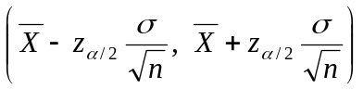

where z_{α/2} is the z-value leaving an area of α/2 to the right.

b. when σ is unknown

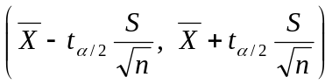

where t_{α/2} is the t-value with v = n - 1 degrees of freedom leaving an area of α/2 to the right.

Remarks:

1. The above formulas hold strictly for random samples from a normal distribution. However, they provide good approximate (1-α)100% confidence intervals when the distribution is not normal provided the sample size is large, i.e. n > 30.

2. If σ² is unknown and n > 30, use

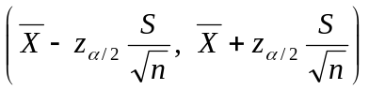

where z_{α/2} is the z-value leaving an area of α/2 to the right.

Examples:

1. An electrical firm manufactures light bulbs that have a length of life that is normally distributed, with a standard deviation of 40 hours. If a random sample of 25 bulbs has a mean life of 780 hours, find a 95% confidence interval for the population mean of all bulbs produced by this firm.

2. Regular consumption of presweetened cereals contribute to tooth decay, heart disease, and other degenerative diseases, according to a study by Dr. M. Albreight of the National Institute of Health and Dr. D. Solomon, Professor of Nutrition and Dietetics at the University of London. In a random sample of 20 similar servings of Alpha-Bits, the mean sugar content was 11.3 grams with a standard deviation of 2.45 grams. Assuming that the sugar content is normally distributed, construct a 95% confidence interval for the mean sugar content for single servings of Alpha-Bits.

3. A random sample of 100 automobile owners shows that an automobile is driven on the average 23,500 kilometers per year, in the state of Virginia, with a standard deviation of 3900 kilometers. Construct a 99% confidence interval for the average number of miles an automobile is driven annually in Virginia.

8.3 ESTIMATING THE DIFFERENCE BETWEEN TWO POPULATION MEANS

If we have two populations with means μ₁ and μ₂ and standard deviations σ₁ and σ₂, respectively, a point estimator of the difference between μ₁ and μ₂ is the statistic 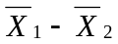.

Types of Sampling:

- selecting two independent samples
- paired sampling

Paired sampling is used to overcome the difficulty imposed by extraneous differences between two groups when testing the difference between 2 means. This is achieved by “matching” or studying 2 related samples. Matching may be achieved by:

- using the same subject in the 2 samples
- pairing of subjects with respect to any extraneous variable which might affect or influence the outcome.

(1-α)100% Confidence Interval for μ₁ - μ₂

- Based on Two Independent Samples

- 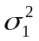 and 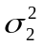 known
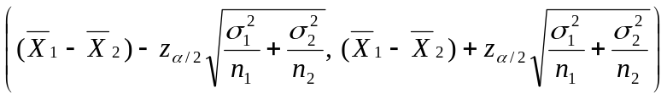

- = but unknown
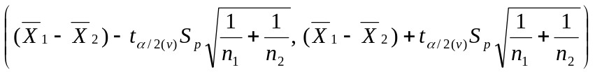

where 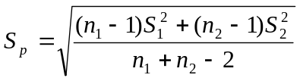 and v = n₁ + n₂ - 2

- ≠ but unknown
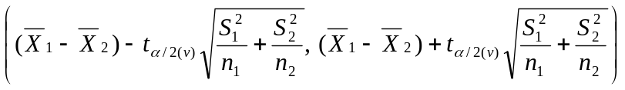

where 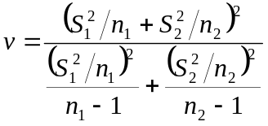

Remarks:

1. These formulas hold strictly for independent samples selected from Normal populations. However, they provide good approximate (1-α)100% confidence intervals when the distributions are not Normal provided both n₁ and n₂ are greater than 30.

2. If and are unknown but n₁ and n₂ are greater than 30, use
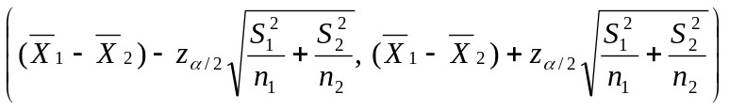
3. Even if the population variances are considerably different, formula (b) will still provide a good estimate provided that n₁=n₂ and both populations are normal. Therefore, in a planned experiment, one should make every effort to equalize the size of the samples.

Examples:

1. A statistics test was given to a random sample of 50 girls and another random sample of 75 boys. The mean score of the girls is 80 with a standard deviation of 4 and the mean score of the boys is 86 with a standard deviation of 6. Find a 95% confidence interval for the difference μ_{B} - μ_{G}.

2. Students may choose between a 3-unit course in Physics without lab and a 4-unit course with lab. The final written examination is the same for each section. The mean score of a random sample of 12 students in the section with lab is 84 with a standard deviation of 4, and the mean score of another random sample of 18 students in the section without lab is 77 with a standard deviation of 6. Find a 99% confidence interval for the difference between the mean grades for the two courses. Assume the populations to be approximately normally distributed with equal variances.

3. The following data represent the running time of a random sample of films produced by two motion picture companies:

Time (minutes)

Company 1 103 94 110 87 98
Company 2 97 82 123 92 175 88 118

Compute a 90% confidence interval for the difference between the mean running time of films produced by the two companies. Assume that the running times for each of the companies are approximately normally distributed with unequal variances.

- Based on Two Related/Paired Samples

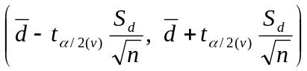

where d_{i} = x_{i} - y_{i}
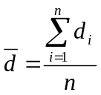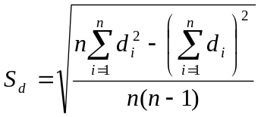
v = n-1 n = number. of pairs

Examples:

1. It is claimed that a new diet will reduce a person’s weight by 4.5 kilograms on the average in a period of 2 weeks. The weights of a random sample of 7 women who followed this diet were recorded before and after a 2-week period:

Woman

1 2 3 4 5 6 7

Weight Before 58.5 60.3 61.7 69.0 64.0 62.6 56.7
Weight After 60.0 54.9 58.1 62.1 58.5 59.9 54.4

Compute a 95% confidence interval for the mean difference in the weight. Assume the distribution of weights to be approximately normal.

- Twenty college freshmen were divided into 10 pairs, each member of the pair having approximately the same IQ. One of each pair was selected at random and assigned to a mathematics section using programmed materials only. The other member of each pair was assigned to a section in which the professor lectured. At the end of the semester each group was given the same examination and the following results were recorded.

Pair 1 2 3 4 5 6 7 8 9 10

Programmed 76 60 85 58 91 75 82 64 79 88
Materials

Lectures 81 52 87 70 86 77 90 63 85 83

Find a 98% confidence interval for the mean difference in scores of the two learning procedures. Assume normality.

8.4. ESTIMATING PROPORTIONS

In a binomial experiment a point estimator of the proportion p is 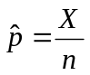, where X represents the number of successes in n trials.

If the unknown proportion is not expected to be too close to 0 or 1 and n is large, an approximate (1-α)100% confidence interval for p is given by

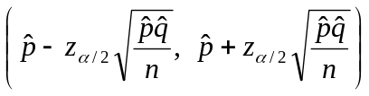

Example:

In a random sample of 200 students who enrolled in Math 17, 138 passed on their first take. Construct a 95% confidence interval for the population proportion of students who passed Math 17 on their first take.

8.5 ESTIMATING THE DIFFERENCE OF TWO PROPORTIONS

Given 2 independent random samples of size n₁ and n₂ , a point estimator of the difference between the two proportions p₁ and p₂ is given by 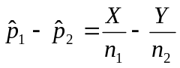, where X is the number of successes in n₁ trials (first sample) and Y is the number of successes in n₂ trials (second sample).

An approximate (1-α)100% confidence interval for p₁ - p₂ when n₁ and n₂ are large is
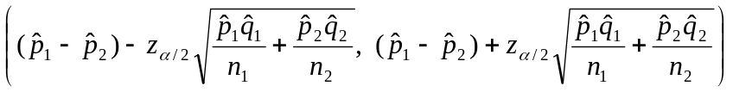

Example:

In a random sample of 200 students, 78 of the 120 females and 60 of the 80 males passed Math 17 on their first take. Construct a 95% confidence interval for p₁- p₂, where p₁ and p₂ are the true proportions of females and males, respectively, who passed Math 17 on their first take.

8.6 SAMPLE SIZE DETERMINATION

Sample Size for Estimating μ

In random sampling, if will be used to estimate μ, we can be (1-α)100% confident that that the error will not exceed a specified amount, e, when the sample size is

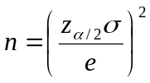

Example:

An electrical firm manufactures light bulbs that have a length of life that is approximately normally distributed, with a standard deviation of 40 hours. How large a sample is needed if we wish to be 95% confident that the sample mean will be within 10 hours of the true mean?

Sample Size for Estimating p

If will be used to estimate p, then we can be (1-α)100% confident that the error will not exceed a specified amount, e, when the sample size is
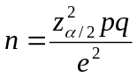

When the value of p is unknown or cannot be approximated, then using p=0.5 produces the maximum value of pq=0.25. Hence a conservative formula for the sample size is
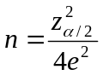

Example:

Use the conservative formula to determine the sample size needed if we want to be 95% confident that our estimate of p is within 0.05 of the true value.

CHAPTER 9

Tests of Hypothesis

9.1 BASIC CONCEPTS OF STATISTICAL HYPOTHESIS TESTING

Definition of Terms

1. A statistical hypothesis is an assertion or conjecture concerning one or more populations.

2. The null hypothesis (Ho) is the hypothesis that is being tested; it represents what the experimenter doubts to be true.

- The alternative hypothesis (Ha) is the operational statement of the theory that the experimenter believes to be true and wishes to prove. It is the contradiction of the null hypothesis.

- A one-tailed test of hypothesis is a test where the alternative hypothesis specifies a one-directional difference for the parameter of interest.

Examples:

a. Ho: μ = 14 vs. Ha: μ > 14
b. Ho: μ = 14 vs. Ha: μ < 14
c. Ho: μ₁ - μ₂ = 0 vs. Ha: μ₁ - μ₂ > 0
d. Ho: μ₁ - μ₂ = 0 vs. Ha: μ₁ - μ₂ < 0

A two-tailed test of hypothesis is a test where the alternative hypothesis does not specify a directional difference for the parameter of interest.

Examples:

a. Ho: μ = 14 vs. Ha: μ ≠ 14
b. Ho: μ₁ - μ₂ = 0 vs. Ha: μ₁ - μ₂ ≠ 0

5. A test statistic is a statistic whose value is calculated from sample measurements and on which the statistical decision will be based.

6. The critical region or rejection region is the set of values of the test statistic for which the null hypothesis will be rejected. The acceptance region is the set of values of the test statistic for which the null hypothesis will not be rejected. The acceptance and rejection regions are separated by a critical value of the test statistic.

7. The Type I error is the error made by rejecting the null hypothesis when it is true. The probability of a Type I error is denoted by α.

The Type II error is the error made by accepting (not rejecting) the null hypothesis when it is false. The probability of a Type II error is denoted by β.

 | Null Hypothesis
Decision | True | False
Reject Ho | Type I error | Correct decision
Accept Ho | Correct decision | Type II error

- The level of significance, α, is the maximum probability of Type I error the researcher is willing to commit.

Steps in Hypothesis Testing

1. State the null hypothesis (Ho) and the alternative hypothesis (Ha).
2. Choose the level of significance α.
- Select the appropriate test statistic and establish the critical region.
- Collect the data and compute the value of the test statistic from the sample data.
5. Make the decision. Reject Ho if the value of the test statistic belongs in the critical region. Otherwise, do not reject Ho.

9.2 TESTING A HYPOTHESIS ON THE POPULATION MEAN

Ho | Test Statistic | Ha | Critical Region
a. σ known
μ = μ_{o} | 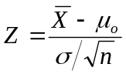 | μ < μ _{o}  μ > μ_{o}  μ ≠ μ_{o} | z < - z_{α}  z > z_{α}  | z | > z_{α/2}
b. σ unknown
μ = μ_{o} | 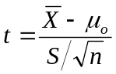  υ = n – 1 | μ < μ_{o}  μ > μ_{o}  μ ≠ μ_{o} | t < - t_{α}  t > t_{α}  | t | > t_{α/2}

Remarks:

1. The above tests are exact α-level tests for samples from a normal distribution. However, they provide good approximate α-level test when the distribution is not normal provided that the sample size is large, i.e. n > 30.

2. If σ is unknown and n > 30, use the test in (a) replacing the test statistic by
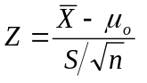

Examples:

- Test Ho: μ=50 vs Ha: μ≠50 if a random sample of 16 subjects had mean 48 and standard deviation of 5.8 at 0.05 level of significance. Assume that the sample was taken from a Normal population with standard deviation of 6.

2. It is claimed that an automobile is driven on the average less than 25,000 kilometers per year. To test this claim, a random sample of 100 automobile owners are asked to keep a record of the kilometers they travel. Would you agree with this claim if the random sample showed an average of 23,500 kilometers and a standard deviation of 3,900 kilometers? Use a 0.01 level of significance.

3. According to Dietary Goals for the United States (1977), high sodium intake may be related to ulcers, stomach cancer, and migraine headaches. The human requirement for salt is only 230 milligrams per day, which is surpassed in most single servings of ready-to-eat cereals. A random sample of 20 similar servings of Special K had mean sodium content of 244 milligrams of sodium and a standard deviation of 24.5 milligrams. Is there sufficient evidence to believe that the average sodium content for single servings of Special K exceeds the human requirement for salt at α=0.025? at α = 0.05? at α = 0.10? Assume normality.
The following remarks hold for any test:

1. For the same data set, as α increases the size of the critical region also increases. Consequently, if Ho is rejected at α-level of significance then Ho will also be rejected at a higher level of significance using the same data. For example, if Ho is rejected at α = 0.05 then testing at α = 0.1 will also lead to the rejection of Ho. However, Ho will not necessarily be rejected at α = 0.01.

2. The Type I error and Type II error are related. For a fixed sample size n, a decrease in the probability of one will result in an increase in the probability of the other. However, increasing the sample size will result in the reduction of both probabilities.

- An alternative way to report the results of the test is to report the p-value. The p-value is the smallest value of α for which Ho will be rejected based on sample information. Reporting the p-value will allow the reader of the published research to evaluate the extent to which the data disagree with Ho. In particular, it enables each reader to choose their personal value of α.

If p-value < α then Ho is rejected. Otherwise, Ho is not rejected.

9.3. TESTING THE DIFFERENCE BETWEEN TWO POP’N MEANS

- Based on 2 independent samples
Ho | Test Statistic | Ha | Critical region
a. 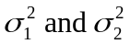 known
μ₁ - μ₂ = d_{o} | 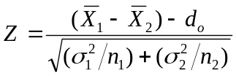 | μ₁ - μ₂ < d _{o}  μ₁ - μ₂ > d_{o}  μ₁ - μ₂ ≠ d_{o} | z < - z_{α}  z > z_{α}  | z | > z_{α/2}
b. 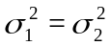 but unknown
μ₁ - μ₂ = d_{o} | 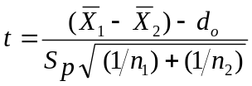  υ = 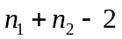  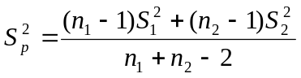 | μ₁ - μ₂ < d _{o}  μ₁ - μ₂ > d_{o}  μ₁ - μ₂ ≠ d_{o} | t < - t_{α}  t > t_{α}  | t | > t_{α/2}
c. 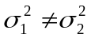 and unknown
μ₁ - μ₂ = d_{o} | 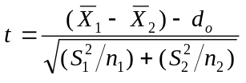  υ = 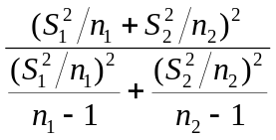 | μ₁ - μ₂ < d _{o}  μ₁ - μ₂ > d_{o}  μ₁ - μ₂ ≠ d_{o} | t < - t_{α}  t > t_{α}  | t | > t_{α/2}
- Based on 2 related samples
Ho | Test Statistic | Ha | Critical region
μ_{D} = d_{o} | 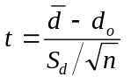  υ = n - 1 | μ_{D} < d_{o}  μ_{D} > d_{o}  μ_{D} ≠ d_{o} | t < - t_{α}  t > t_{α}  | t | > t_{α/2}

Remark: The remarks made in Chapter 8.3 relative to the use of a given statistic apply to the tests described here.

Examples:

1. A statistics test was given to 50 girls and 75 boys. The girls made an average of 80 with a standard deviation of 4 and the boys had an average of 86 with a standard deviation of 6. Is there sufficient evidence at 0.05 level of significance that the average grades of girls and boys differ?

2. A study was made to determine if the subject matter in a physics course is better understood when a lab constitutes part of the course. Students were allowed to choose between a 3-unit course without lab and a 4-unit course with lab. In the section with lab, a sample of 11 students had an average grade of 85 with a standard deviation of 4.7, and in the section without lab, a sample of 17 students had an average grade of 79 with a standard deviation of 6.1. Would you say that the laboratory course increases the average grade by more than 5 points? Use a 0.01 level of significance and assume the populations to be approximately normally distributed with equal variances.

3. The following data represent the running time of films produced by two motion picture companies:
Time (minutes)
Company 1 103 94 110 87 98
Company 2 97 82 123 92 175 88 118

Test the hypothesis that the average running time of films produced by company 2 exceeds the average running time of films produced by company 1 by 10 minutes against the one-sided alternative that the difference is more than 10 minutes. Use a 0.1 level of significance and assume the distributions of times to be approximately normal with unequal variances.

4. A taxi company is trying to decide whether the use of radial tires instead of regular belted tires improves fuel economy. Twelve cars were driven twice over a prescribed test course, each time using a different type of tires (radial and belted) in random order. The mileage, in kilometers per liter, were recorded as follows:

Kilometers per liter

Cars Radial Tires Belted Tires

1 4.2 4.1
2 4.7 4.9
3 6.6 6.2
4 7.0 6.9
5 6.7 6.8
6 4.5 4.4
7 5.7 5.7
8 6.0 5.8
9 7.4 6.9
10 4.9 4.7
11 6.1 6.0
12 5.2 4.9

At the 0.025 level of significance, can we conclude that cars equipped with radial tires give better fuel economy than those equipped with belted tires? Assume the populations to be normally distributed.

9.4 TESTING A HYPOTHESIS ON PROPORTIONS

Consider the problem of testing the hypothesis that the proportion of successes in a binomial experiment equals some specified value.

If the unknown proportion is not expected to be too close to 0 or 1 and n is large, a large sample approximation is given by:

Ho | Test Statistic | Ha | Critical region
p = p_{o} | 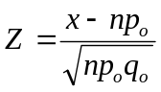 | p < p_{o}  p > p_{o}  p ≠ p_{o} | z < - z_{α}  z > z_{α}  | z | > z_{α/2}

Example:

A commonly prescribed drug on the market for relieving nervous tension is believed to be only 60% effective. Experimental results with a new drug administered to a random sample of 100 adults who were suffering from nervous tension showed that 70 received relief. Is this sufficient evidence to conclude that the new drug is superior to the one commonly prescribed? Use a 0.05 level of significance.

9.5 TESTING THE DIFFERENCE BETWEEN TWO PROPORTIONS

Consider a situation in which a researcher wishes to compare the proportions of an attribute between two populations. For example, he is interested in assessing whether the proportion of female household heads is greater in urban areas than in rural localities; or a marketing manager would consider packaging a product towards working mothers if, based on a planned research, the proportion of potential purchasers is higher in this group compared to the group of non-working mothers. Thus, the researcher is, in general, interested in testing the null hypothesis Ho: p₁ = p₂, where 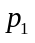 and 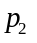 are the two population proportions of interest.

The testing procedure involves selection of independent samples of size n₁ and n₂ from two binomial populations. The sample proportions 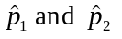 are computed and the common (population) proportion p is given as the pooled estimate 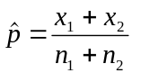 where 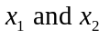 are the observed number of units possessing the attribute of interest in the two samples. The test is as follows:

Ho | Test Statistic | Ha | Critical region
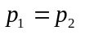 | 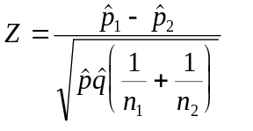 | p₁ < p₂  p₁ > p₂  p₁ ≠ p₂ | z < - z_{α}  z > z_{α}  | z | > z_{α/2}

Example:

In a survey of 200 students, 78 of the 120 females in the sample passed Math 17 on their first take while this figure is 60 among the 80 males. Will you agree that the proportion of males who passed Math 17 on their first take is higher than the proportion of females who passed the same course on their first take? Test at α=0.05.

9.6. TEST FOR INDEPENDENCE

The test for independence is used to determine whether two variables are related or not. For example, we might test whether a person’s music preference is related to his intelligence as measured by IQ. We then take a random sample and for each subject determine their music preference and classify their IQ’s into different categories (high, medium, low). The observed frequencies are presented in what is known as a contingency table shown below:

Music | IQ
Preference | High | Medium | Low | Total
Classical | 40 | 26 | 17 | 83
Pop | 47 | 59 | 25 | 131
Rock | 83 | 104 | 79 | 266
Total | 171 | 189 | 121 | 480

A contingency table containing r rows and c columns is referred to as an rxc table. The row and column totals are called marginal frequencies. Note that in a test for independence, these marginal frequencies are not fixed in advance but depends instead on the way the sample distributed itself across the various cells in the table.

Procedure:

1. State the null and alternative hypothesis.

Ho: The two variables are independent
Ha: The two variables are not independent.

2. Choose the level of significance.

3. Compute the test statistic, given by
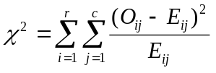
where O_{ij}= observed number of cases in the i^{th} row of the j^{th} column
E_{ij} = expected number of cases under Ho
= 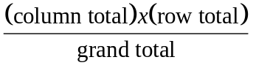

4. Decision Rule: Reject Ho if 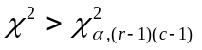.
Remarks:

1. The test is valid if at least 80% of the cells have expected frequencies of at least 5 and no cell has an expected frequency ≤ 1.

2. If many expected frequencies are very small, researchers commonly combine categories of variables to obtain a table having larger cell frequencies. Generally, one should not pool categories unless there is a natural way to combine them.

3. For a 2x2 contingency table, a correction called Yates’ correction for continuity is applied. The formula then becomes
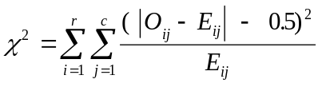

Example:

Using the table above:

Ho: Music preference and intelligence are independent
Ha: Music preference and intelligence are not independent

Music | IQ
Preference | High | Medium | Low | Total
Classical | 40 (29.4) | 26 (32.7) | 17 (20.9) | 83
Pop | 47 (46.4) | 59 (51.6) | 25 (33.0) | 131
Rock | 83 (94.2) | 104 (104.7) | 79 (67.1) | 266
Total | 171 | 189 | 121 | 480

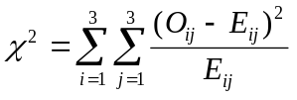

= 12.38

at α = 0.05, 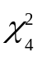= 9.488

Decision: Since 12.38 > 9.488, reject Ho. There is sufficient evidence at 0.05 level of significance that music preference and intelligence are not independent.
CHAPTER 10

Regression and Correlation

  - Correlation Coefficient

Definition. The linear correlation coefficient, denoted by ρ (rho), is a measure of the strength of the linear relationship existing between two variables, X and Y, that is independent of their respective scales of measurement.

Remarks:
- -1 < ρ < 1
- A positive ρ means that the line slopes upward to the right; a negative ρ means that it slopes downward to the right.
- When ρ is 1 or –1, there is perfect linear relationship between X and Y and all the points (x,y) fall on a straight line. A ρ close to 1 or –1 indicates a strong linear relationship but it does not necessarily imply that X causes Y or Y causes X. It is possible that a third variable may have caused the change in both x and y, producing the observed relationship.
- If ρ = 0 then there is no linear correlation between X and Y. A value of ρ = 0, however, does not mean a lack of association. Hence, if a strong quadratic relationship exists between X and Y, we will still obtain a zero correlation to indicate a nonlinear relationship.

Definition. The Pearson product moment coefficient of correlation, denoted by r, is

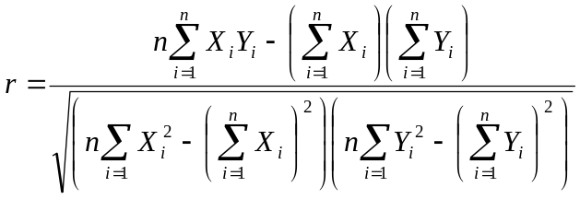

Remarks:
- r is used to estimate ρ based on a random sample of n pairs of measurements (X_{i}, Y_{i}), i=1,…,n.
- 0 < r < 1
- Just like ρ, when r = 1 or –1, all the points (x_{i},y_{i}), i=1,…,n, fall on a straight line; when r=0, they are scaterred and give no evidence of a linear relationship. Any other value of r suggests the degree to which the points tend to be linearly related.
Some Typical Scatterplots with Approximate Values of r:

(a) Strong positive linear correlation; r is near 1

y *
**
* *
*
* *
*

x

(b) Strong negative linear correlation; r is near -1

y *
* *
* *
*
* *
*
x

- No apparent linear correlation; r is near 0

y * * * *
* * * * *
* * *
* *
*

x

- Quadratic relation, r is near 0

y *
* *
* *
* *
* *

x

Example: Consider the data given below. Let X represent the lot size and Y represent the man hours required.

 | Observation | Lot Size | Man Hours
 | No. | (X) | (Y)
 | 1 | 30 | 73
 | 2 | 20 | 50
 | 3 | 60 | 128
 | 4 | 80 | 170
 | 5 | 40 | 87
 | 6 | 50 | 108
 | 7 | 60 | 135
 | 8 | 30 | 69
 | 9 | 70 | 148
 | 10 | 60 | 132

Construct the scatterplot and compute r.

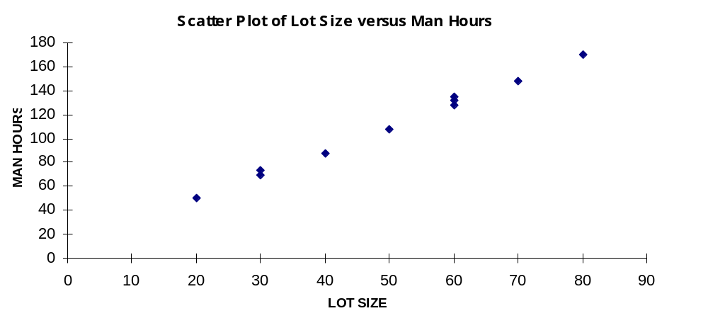
ΣX = | 500
ΣY = | 1100
ΣXY = | 61800
ΣX² = | 28400
ΣY² = | 134660
r = |  | 0.99780

  - Testing the Correlation Coefficient

Ho | Test Statistic | Ha | Critical Region
ρ = 0 | 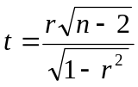  v = n – 2 | ρ < 0  ρ > 0  ρ ≠ 0 | t < -t_{α}  t > t_{α}  | t | > t_{α/2}

  - Simple Linear Regression

Equation of a Straight Line

y = β_{o} + β₁x where β₀ = y-intercept ; the value of y when x=0
β₁ = slope of the line; change in y for a 1-unit increase in x

Deterministic Model vs Probabilistic Model

The linear model y = β_{o} + β₁x is said to be a deterministic mathematical model because, when a value of x is substituted into the equation, the value of y is determined and no allowance is made for error.

In contrast, the linear model y = β_{o} + β₁x + ∈ (where ∈ is a random error, the difference between an observed value of y and mean value of y for a given value of x) is said to be a probabilistic mathematical model because this model assumes that for any given value of x the observed value of y varies in a random manner and possesses a probability distribution with mean E(Y|X=x) = β_{o} + β₁x.

Definition: The simple linear regression model is given by:

Y = β_{o} + β₁X + ∈

where Y = response variable
X = explanatory or predictor variable
∈ = random error
β_{o} = y-intercept
β₁ = slope of the line

Linear regression models that involve two or more explanatory variables are called multiple regression models.
Assumptions of the Model

For any given value x, the response variable Y possesses a normal distribution, with a mean value given by the equation E(Y|X=x) = β_{o} + β₁x and with a variance of σ². Furthermore, any one value of Y is independent of every other value.

Estimating β_{o} and β₁

The formulas for b_{o} (estimate of β_{o}) and b₁ (estimate of β₁) are derived using the method of least squares where the “best-fitting” line is selected as the one that minimizes the sum of squares of the deviations of the observed value of Y from those predicted by the model. The formulas are

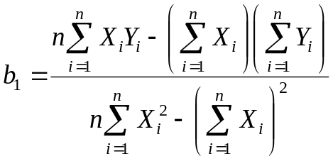

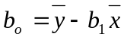

Predicting the Value of Y Given X=x

The predicted value of Y, denoted by 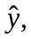 is computed by substituting x in the prediction equation

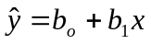

Remarks:

- The calculated prediction equation is appropriate only for the relevant range of X that includes all values of X used in developing the regression model. Hence, when predicting Y for a given value of X, one may interpolate only within this relevant range of the X values. Extrapolation in predicting Y for values of X outside the relevant range would result in a serious prediction error.

- If X = 0 is not included in the range of the sample data, then b₀ will not have a significant interpretation.
Inferences Concerning the Slope of the Line, β₁

An estimator for σ² is
S² = 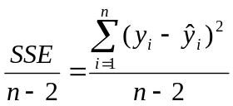

where SSE stands for sum of squares of errors.

A (1-α)100% Confidence Interval for β₁ is

( b₁ - t_{α/2 (v= n - 2)} s_{b1} , b₁ ₊ t_{α/2 (v= n - 2)} s_{b1})

where s_{b1} = 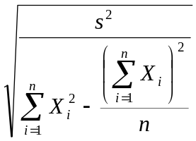

Test of Hypothesis Concerning β₁

Ho | Test Statistic | Ha | Critical Region
β₁ = 0 | 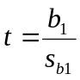  v = n-2 | β₁ < 0  β₁ > 0  β₁ ≠ 0 | t < -t_{α}  t > t_{α}  | t | > t_{α/2}

Example:

Suppose a researcher wishes to investigate the relationship between the achieved grade-point index (GPI) and the starting salary of recent graduates majoring in business. A random sample of 30 recent graduates majoring in business is drawn, and the data pertaining to the GPI and starting salary (in thousands of dollars) are recorded for each individual in the following table:

 | Individual | GPI | Starting Salary
 | No. | (X) | (Y)
 | 1 | 2.7 | 17.0
 | 2 | 3.1 | 17.7
 | 3 | 3.0 | 18.6
 | 4 | 3.3 | 20.5
 | 5 | 3.1 | 19.1
 | 6 | 2.4 | 16.4
 | 7 | 2.9 | 19.3
 | 8 | 2.1 | 14.5
 | 9 | 2.6 | 15.7
 | 10 | 3.2 | 18.6
 | 11 | 3.0 | 19.5
 | 12 | 2.2 | 15.0
 | 13 | 2.8 | 18.0
 | 14 | 3.2 | 20.0
 | 15 | 2.9 | 19.0
 | 16 | 3.0 | 17.4
 | 17 | 2.6 | 17.3
 | 18 | 3.3 | 18.1
 | 19 | 2.9 | 18.0
 | 20 | 2.4 | 16.2
 | 21 | 2.8 | 17.5
 | 22 | 3.7 | 21.3
 | 23 | 3.1 | 17.2
 | 24 | 2.8 | 17.0
 | 25 | 3.5 | 19.6
 | 26 | 2.7 | 16.6
 | 27 | 2.6 | 15.0
 | 28 | 3.2 | 18.4
 | 29 | 2.9 | 17.3
 | 30 | 3.0 | 18.5

a. Find the equation of the regression line.
b. Find an estimate for the starting salary if the GPI is 2.5.
c. Test for the significance of β₁ at α = 0.05.
d. Compute and interpret the correlation coefficient.
e. Test for the significance of ρ at the 0.01 level of significance.

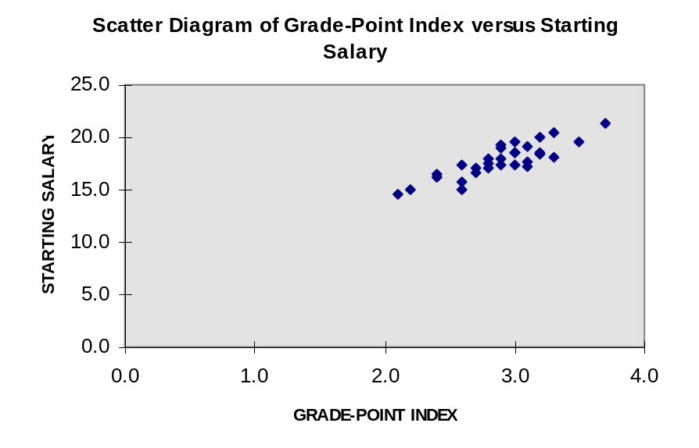

b₀ = | 6.418245
b₁ = | 3.928191
r = | 0.865088
ΣX = | 87.0
ΣY = | 534.3
ΣXY = | 1564.24
ΣX² = | 256.06
ΣY² = | 9593.41

